Introduction
Welcome to Business Report Training!

The MWC Quarterly and Annual reports are important and required to present the status of the MWC Association. This training document will take you through the process of creating this report.
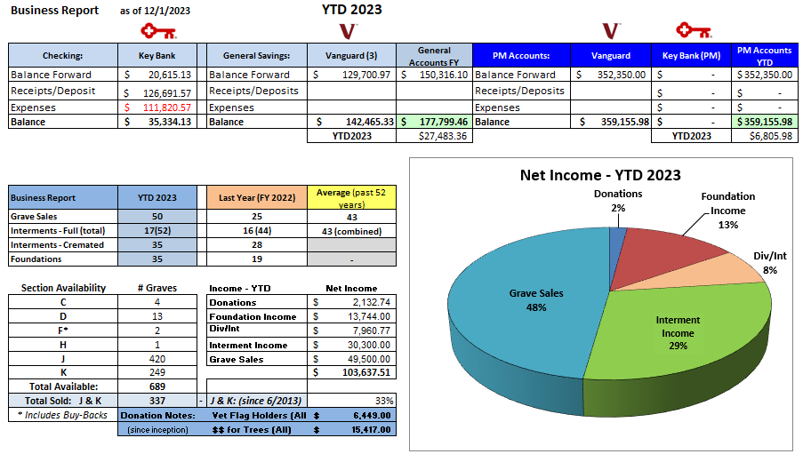
Below is a sample of the quarterly business report:

This is a complex report to generate and requires multiple sources. More details on how to create this report are provided in this ‘Business Reports’.

The NYS Cemetery Division documents and the Treasurer training documents are required to fully understand the requirements and content of this business report process.
A separate training document on how to create the correct Grave Sales numbers for both the Business Reports and the Permanent Maintenance (PM) reports.
Information needed for this business report requires data from:
- QuickBooks Online (QBO)
- KeyBank General Fund (GF) account
- Vanguard GF and PM accounts
- MS Access database
- MS Excel

The KeyBank GF data provides the core of the financial transactions of MWC. All financial transactions must go through this GF account. This is a view of the entire spreadsheet.
The top-left portion is the only part presented in the report. The rest of this spreadsheet provides the data.

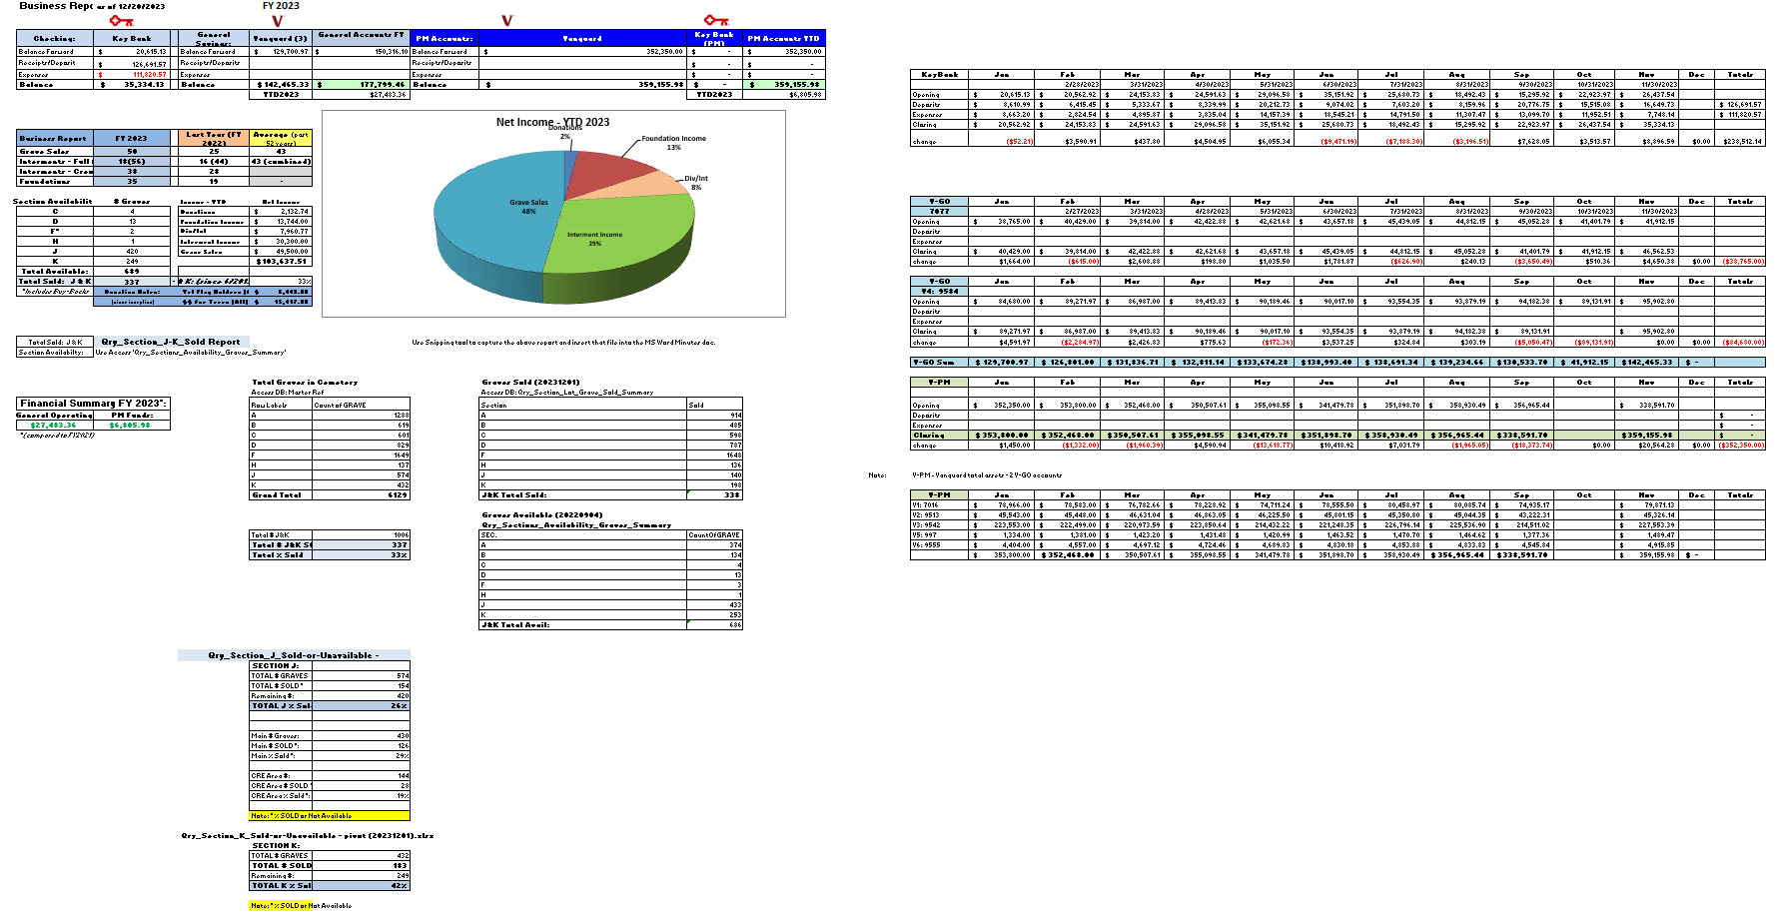

The monthly KeyBank GF statements summarize the ‘Additions’ (Deposits) and ‘Subtractions’ (Expenses). These should be recorded in the monthly data table. This data table feeds the main presentation part of the report.
The data column needs to be updated in the presentation table to show the new data.

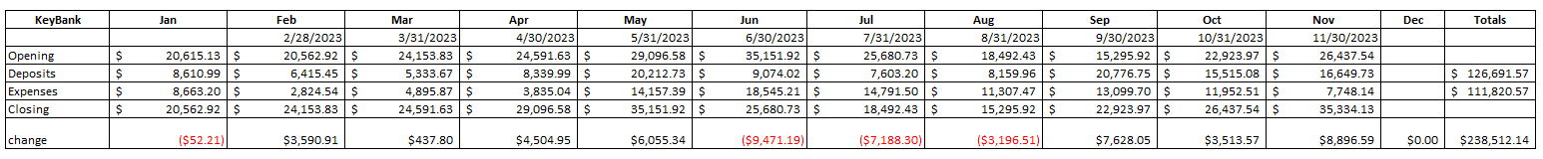
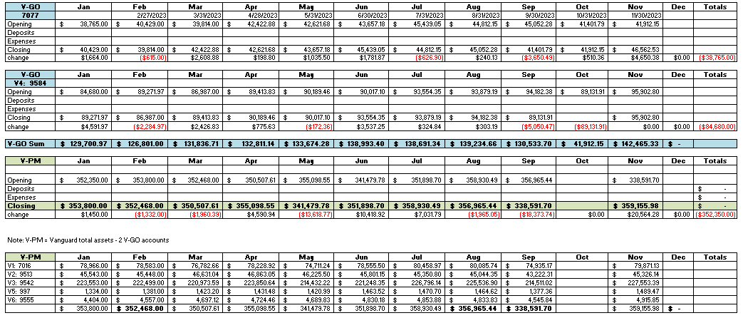
The V-GO 7077 and 9584 Vanguard accounts are the GF Savings accounts. These GF accounts earn dividends and interest that the KeyBank GF account does not. These dividends and interest are transferred to the KeyBank GF account quarterly (by Vanguard).
The V-PM accounts above are the Vanguard PM accounts. These accounts are composed of various funds to provide a balanced growth opportunity. These dividends and interest are also transferred to the KeyBank GF account quarterly (by Vanguard).
QBO will log these dividends and interest transfers into KeyBank GF and PM Dividend and Interest Income.
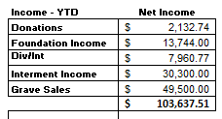
A QBO report will be able to identify and report all dividends and interest for the period or year.
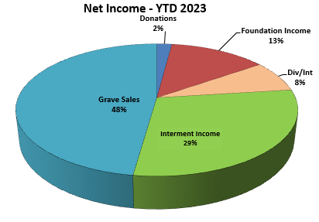
QBO reports can be used to report these income numbers for the required timeframe. Note that these income numbers are NET Income. QBO has P&L reports available for the Foundation and Interment net incomes.
In this report area, Grave Sales is the total income for all grave sales in this report period.
The pie chart is created from the above data table. Adjustments to the chart display may be required to align the leader lines and category labels.

Now things get a bit more complicated…..
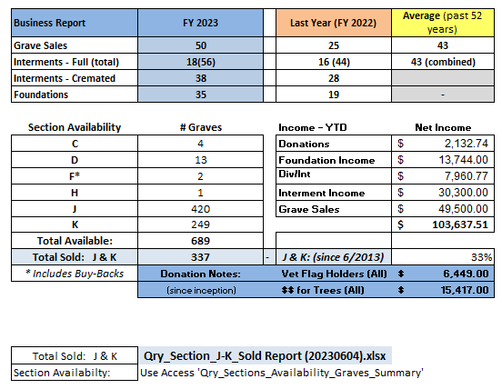
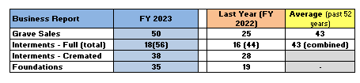
More data analysis is required to accurately compile the rest of this report.

QBO Reports can be used to gather the INTERMENTS data. This report lists the interments by category, FULL vs. CREMATED.
QBO can also be used to report on the foundations.
Grave Sales, the actual number of graves sold, in the report year are more difficult to compile. There is a separate document on how to report the GRAVE SALES on MWC Admin. Multiple ‘tools’ are required. Some of that data will also be used to report the Section Availability numbers.
There is another spreadsheet that lists the numbers by year for Grave Sales, Interments, and the foundations to track and average the trends. The Qry_Section_J-K_Sold Report.xlsx will also be discussed in the Grave Sales report training.

Wrapping Up:
Once all the required data is plugged into the appropriate data cells, the Business Report should be ready to capture.
The area of the report used for distribution will be visible if the Print Area is set up properly. It is recommended that the Print Area of the report also be ‘screen grabbed’ using a tool like MS Snipping Tool to save the image as a PNG format image. This makes the overall quarterly meeting minutes easier to create.

Other Reference materials: All are on the MWC Admin website.

Reports/NYS Cemetery Div
- cemeteries-101-basics
- cemeteries-101-accounting-basics
- Not-For-Profit-Corporation-Law-Article-15-Public-Cemetery-Corporations
- NYS public cemetery regulations
- NYS treasurers-manual-final-100611

Reports/Training
- MWC Treasurer QBO Training
- MWC Treasurer Training
- MWC Sales Training
- MWC Business Reports (this document)
- MWC PM Reports
- MWC Graves SOLD Reports
- MWC Section Maps Training

