a $ ' .


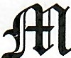apletuoob QCemeterp ssoctatton
150 MIDDLE ROAD

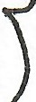
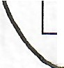
HENRIETTA, NY 14467
Special Flower Fund
Date
·
Name
....
Lot
y
Annual Amount
,
Comments: Stated in Will - $500.00. The income from which is to be used first for the perpetual care of the
Calkins - Perry lot in said cemetery and secondly for placing flowers and maintaining appropriate perennials for annual plantings on the graves pf Wm. Perry and Belle Calkins Perry and thirdly; the remainder thereof to be used for general cemetery maintenance.
Comments: Care of Charlotte A. Parson Fay lot - Fiowers on 5 graves each spring. Bequest - $2,500.00
Comments: Will - $100.00, flowers in vase in May
•
$ 25.00
866
William Per
1948

Date | Name | Lot | Annual Amount
1967 | Sumner D. Fay 8227.1 - Graves 1-5 $125.00

Date |  | Name | Lot | Annual Amount
 | 1947 | Mar E. Sherman | A137 - Grave 4 | $ 5.00

Perpetual Care Fund
Date | Name | Lot | Annual Amount
1953 | Martha C. Smith | A271 - Graves 1-2 | $ 2.50

Comments: Will - $ 50.00, Maintaining my Family Lot

Comments: Will - $500.00, Care for graves of Father and Mother
Date | Name | Lot | Annual Amount
1960 | Ketchum Estate | 8225 - Graves 1-2 | $ 25.00

Date | -  Name | Lot | Annual Amount
1968 | Hazel M. HoriQ | A251 - Grave 3 | $ 5.00

- , -
. - - -- -

Comments: Will - $100.00, Care of Family lot

Permanent Maintenance
Date | Name | Lot | Annual Amount
1955 | -►  Louise Pe;rry Coakley - | A278 - Graves 1-8 | $ 50.00

Comments: Will - John H. Perry Lot, Income used first as far as necessary for maintenance, preservation, and repair of plot and balance for general purpose and care of Cemetery.

Middle Road





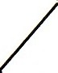


Section B Section A

227
66

225
137

271.1 251
278

_.►N

Visit ;fffilaplebloob <!Cemeterp on the web: http://www.MaplewoodCemetery.org MWC Special Funds (20060624).doc

f
i

ctplefuooi) <tI2m2ier J\5sociaiion
(INCORPORATED 1896}
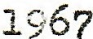


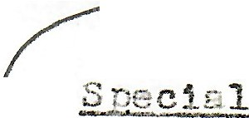
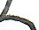

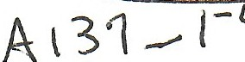

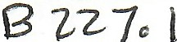
HENRIETTA, NEW YORK 14467
•
Jo
. .
L1sed. !""irst 'for the .Per·r>etual Ccre of tr1e Callrlns .. Pe1..ry
in said cemetery and secondly for J•lacing flowers and
St ted in Will - 500.00. The income from which is to be
Lot
t&- W
r·ern.e1ir1der
(Yj'-) r-e.s·. o·f :';tn. P·e··r-1"1,T .-.::n Pl1 e c··0, 1,::-" l/41,!. r4 L.ft"rI"''tT"it"l· t-.h1r•Al. 't1'.
rr1c1intair1ing app1...opri.s;te r;eren,i.E:.J..s for
c::n11us..l
J:,lantings
1
('>n tl1e
1.:u;.
t!-1ere
...,.., -
of·
r;;._
to
--
- -
...L-..i..- C) .IL v.... (I Cl,t-•
be used f4or gen-sral. cemetery
v .. - --. 'u J
r1ait1t,e11 1r.1ce,
tl1e
on 5
ill V9...Se
\-S


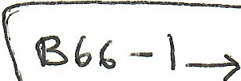



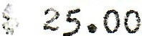

,
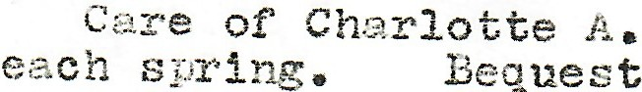
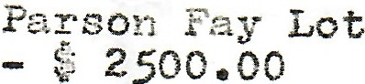
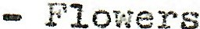
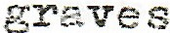
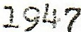
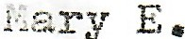
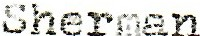


- --

/



1960

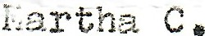


50.00
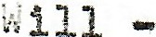

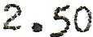
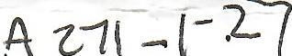
F st!1.te
-
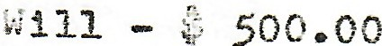

# 271 --

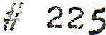

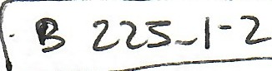

of


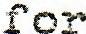

-l'";.A1\J
,. ,_?
_{A}·l n .e,1. 1;
  - :ro"".J..'« ...;'. ( -t

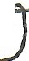
tf 251
-3 ..
·
l ""· ..:.. 0
v,
·-•"'
..
J.,.A.>e-;..) l'.l •
\. 5.00

- t;r
l\•,\ f·1" ..1.... 1 • \... l"V"l". } l""i{) Car·e
.
    - \.JU 0f
!1 r...,it;r..:,,.a1'
J- Y.'

Lot.
{\ ZS{·_.

1955 Lot11se Perry Coa.kley •:·278 
i 111 - J om1. ti .1.:>errJr Lot - I11co111e used.
necessary for r1aj_n.te1-1 .,.:r1ce, p1'\eserv.a ti (>n

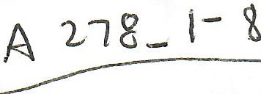

f1.1..st as far a.s
"-•. ...-i V -........,.,....,.. ;
A nn. 1,...$,- i C\.J.,r,t.

plot f111ri bal.9.,11ce f oz.. i ;e11eral Pu:roose t r1d.
.... _I:1.1 d J } j<c c d
. «I:-

¢.

care of Cenetery.


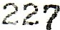

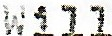
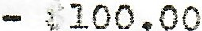
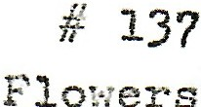

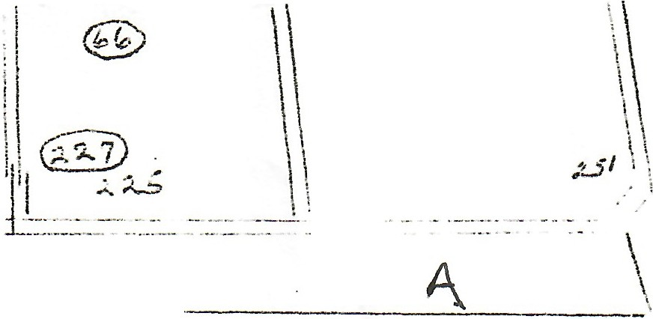

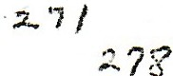
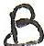

vJ
!
•
•
f
•
!
'i
.t
.. --.
.... - ......
I
l
l
I ,.,5 I
t
I l

'
I
I I
E

- '"

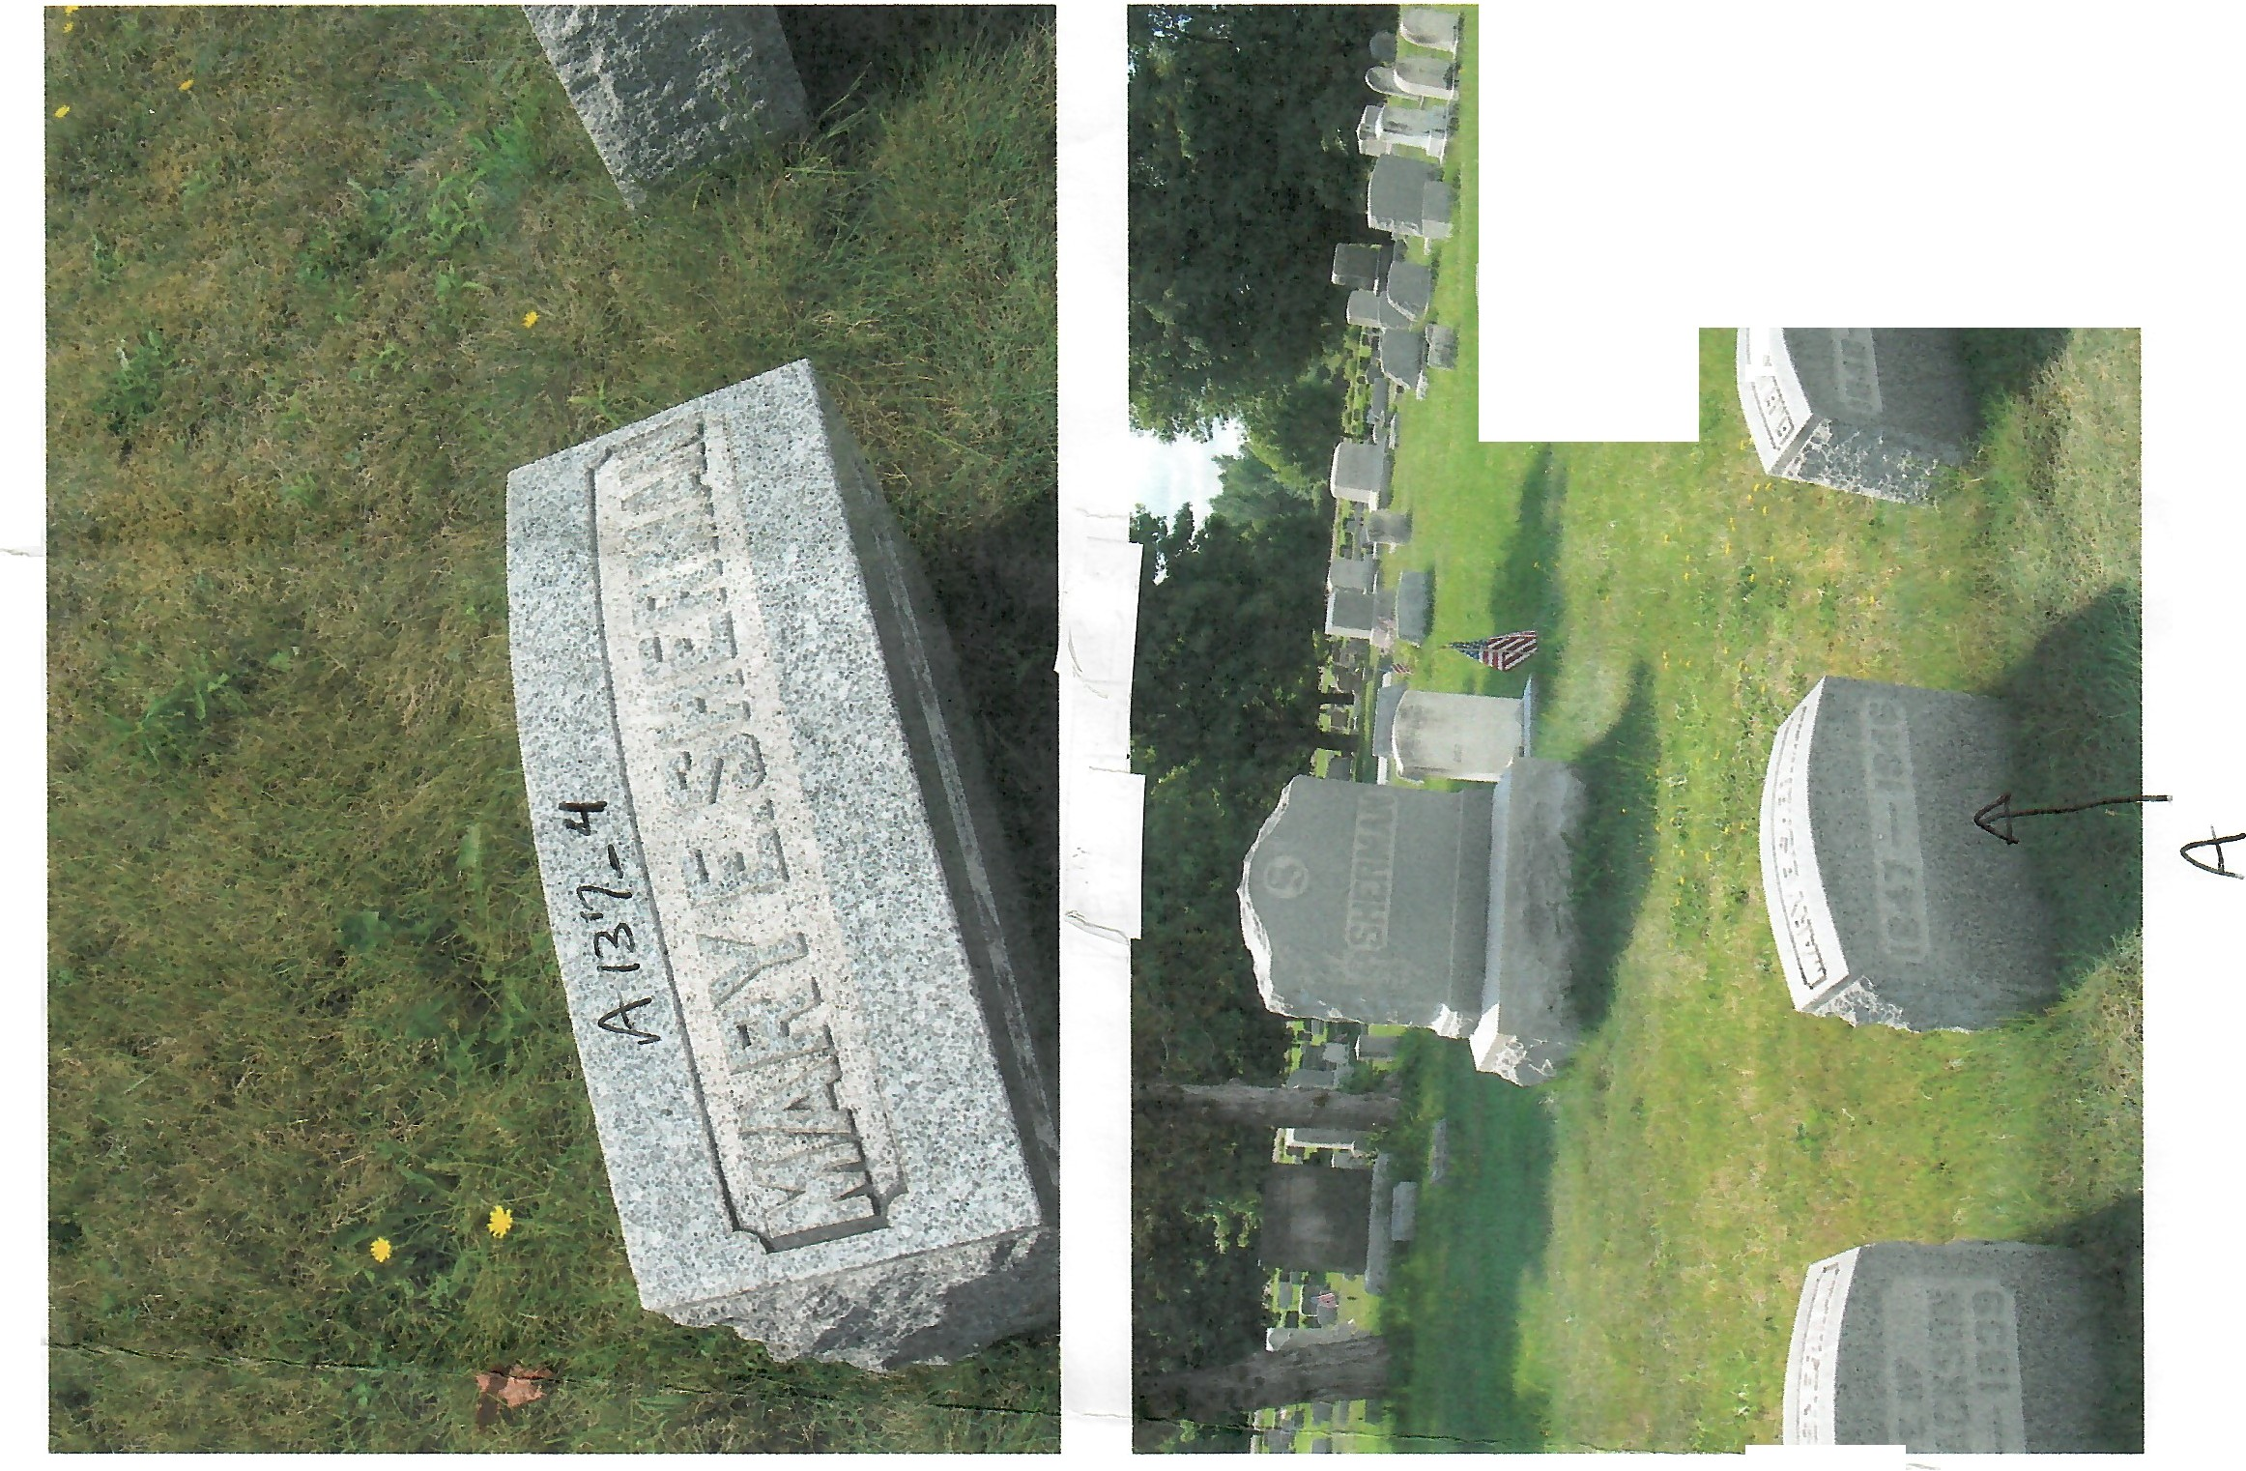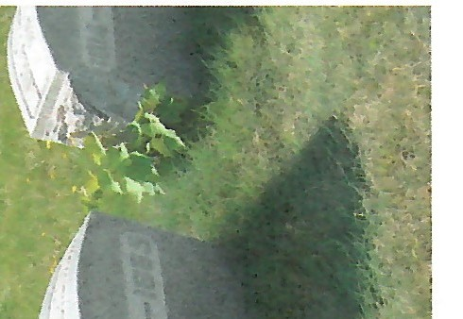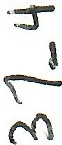
•
4 ,re
\ .
..I
\
·---
---
-

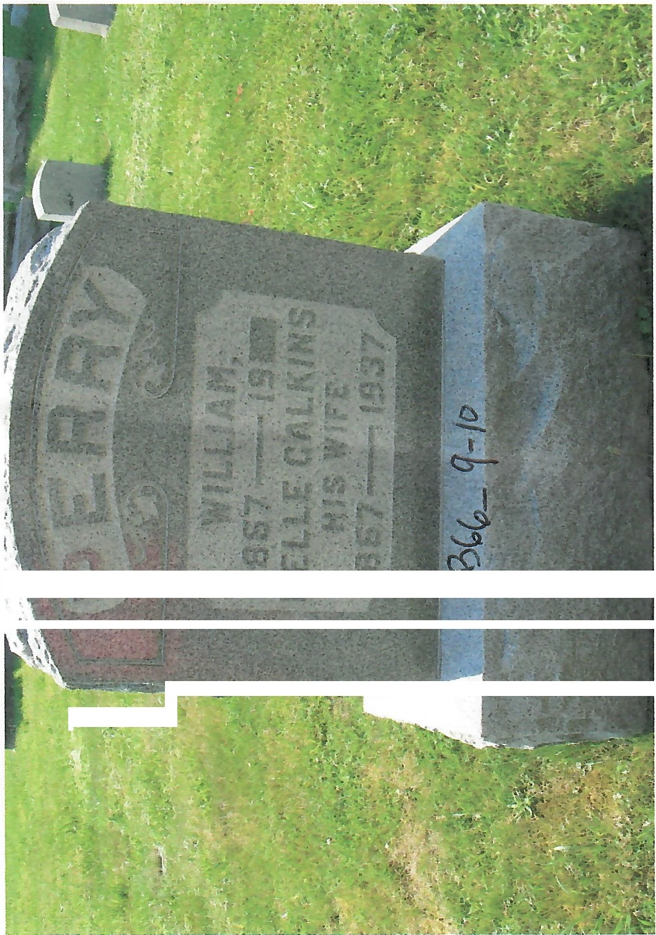
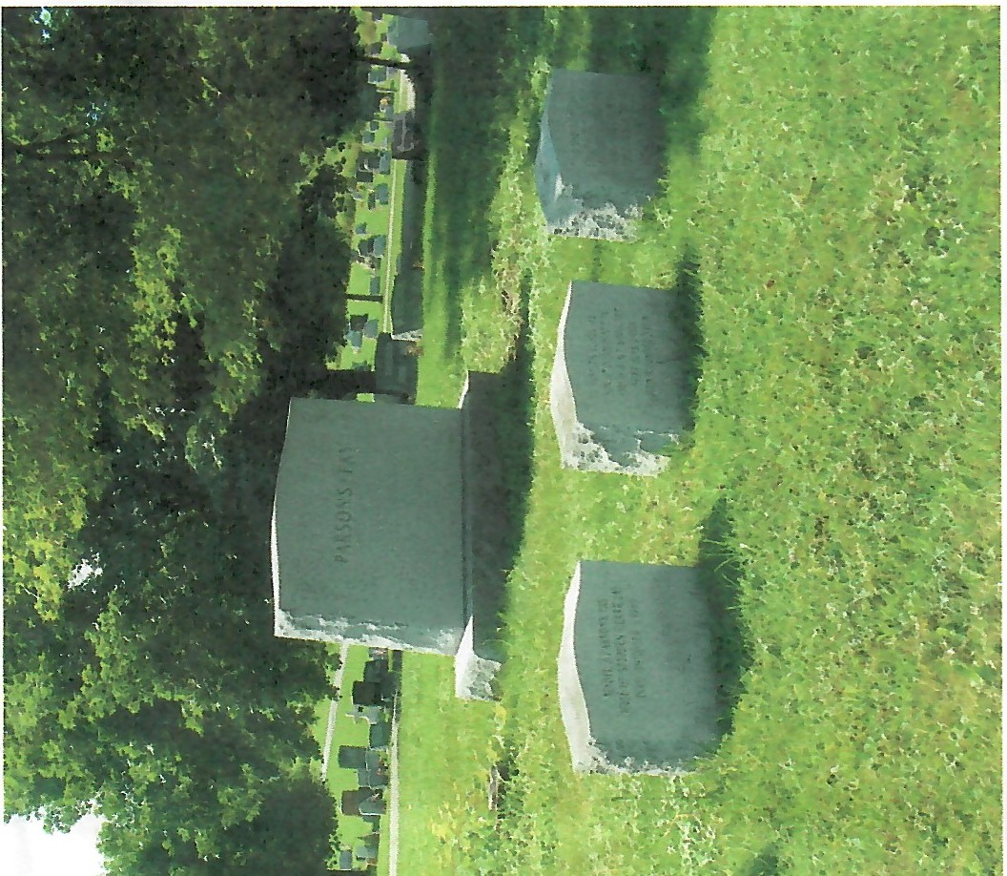
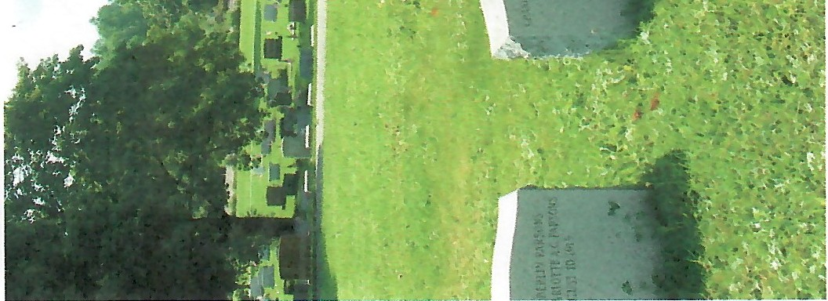
•
.\•
t
•
•
't
•
r

.....-
v

nrt,

