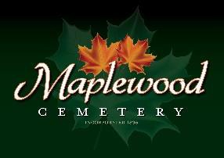

Maplewood Cemetery Association
24 Flinton Run
Churchville, NY 14428
Maplewood Cemetery Association

Quarterly Board Meeting
March 5, 2025
- President John Hatch brought the Directors Quarterly meeting to order.
Secretary’s Report: The 2024 Q4 meeting minutes were read by George. Motion by ___________ to approve, seconded by __________ and approved.

Treasurer’s Business Report: Gary’s Business Report 1st Quarter 2025. A motion to accept was made by _______ seconded by ____________ and approved.

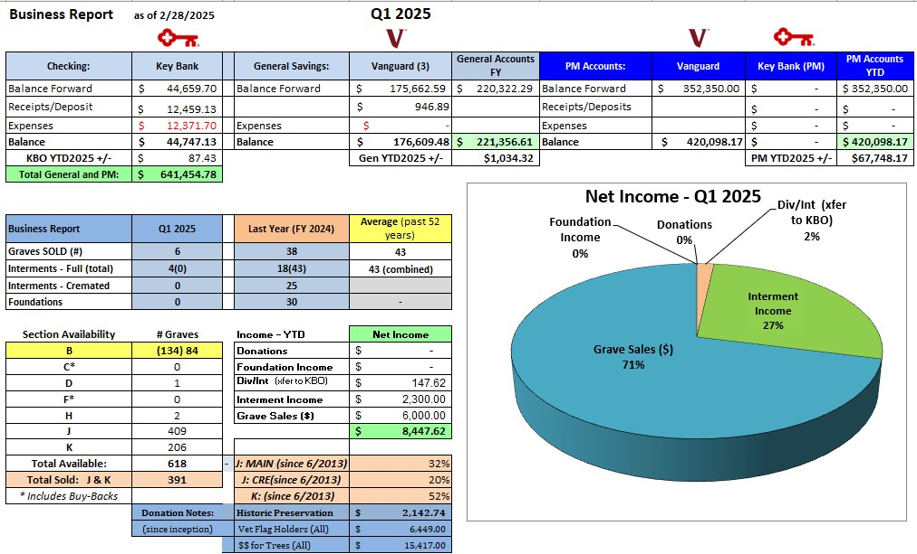

Finance Report: George reported:

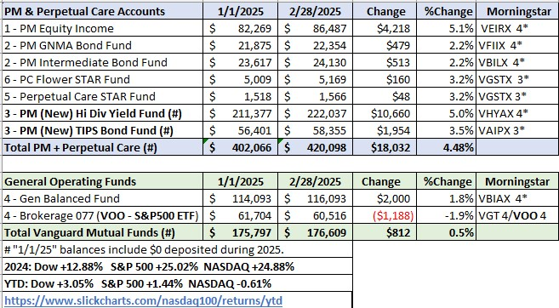

Sunshine Committee: Carol reported nothing.

Superintendent’s Report:

Grounds Report: The berms will be removed by middle road next year and the tree mulched stopped reducing Chris Schaffer’s spring cleanup charges.

Website: The WordPress-based customer website continues to add features, links and photos. The same MaplewoodCemetery.org website address will take you there. The internal website, MaplewoodCemetery.org/mwcadmin has been updated. All board members can access this site without a password.

Database: It continues to be updated locally and uploaded to the MaplewoodCemetery.org/mwcadmin site.

Nominating:

John read the list of directors whose terms are ending, George Zornow, Hank Wallace, John Hatch, Melanie Rajaphoumy, Ray Feasel, Jr. (1– Open Position).
- Motion to approve renewing all to another 3-year term made by ____________, seconded by _________ and approved.
- The new officer nominations are President: John Hatch, 1st Vice – Mark Feasel, 2nd Vice – ________________
- Superintendent – Scott Nevol, Secretary - Linda Stockmaster and Treasurer - Gary Stockmaster
- Motion to approve renewing all officers to a 1-year term made by ____________, seconded by _________ and approved.

Old Business:

MWC Bylaws: The revised bylaws document needs to be approved.
  - Motion made by Gary to approve the Bylaws as revised on 8/18/2024.
    - Motion seconded by ___________ and approved.
- We are waiting for the Town to cut down the remaining dying tree.
- The board needs to continue addressing the succession plans and officer roles and responsibilities as a follow-up to the May 11th Executive meeting. Training is available for the roles needed.
- The Audit Committee needs to be selected.
- Treasurer: A new treasurer or vice treasurer is still an urgent need. All MWC business transactions are managed in this role. Training is available.
- Someone needs to step up to be a vice treasurer to provide continuity and access to all financial operations and accounts.
- Secretary: Who will step up to help as an assistant secretary?
- The ‘Key-3’ directors, John, Scott and Gary, now get together periodically between quarterly board meetings to catch up on all activities and issues. The previous meeting was on January 17, 2025.
- Finance – Taxes and audits:
  - Employee’s W2 forms were sent via Workforce in January 2025.
  - Vendor’s 1099 forms were sent via email in January.
  - NYS Cemetery annual audit report was completed in January.
  - IRS 990 tax-exempt was completed in February.
  - No update on the anticipated NYS Cemetery Division audit. This may now include the years of 2017 through 2024.

New Business:
- Rate Increases: Our contractor rates are increasing. Our January Key-3 meeting reviewed these increases and proposed new rates and charges to be approved by the board and NYS Cemetery Division.
- Budget Planning:
  - Road maintenance should be scheduled.
    - Crack sealing
    - Seal coating, primarily targeting main road.
      - A proposed mowing change was made to reduce the costs of mowing the East and South sections to cover the cost of the road maintenance.
      - Volunteers will mow these sections and reduce those mowing costs by ~$5,500.
  - The old mower’s engine is periodically not running right. Mark suggests we replace the lifters for an estimated $750. This should be reviewed and scheduled.
  - Motion made by Gary to approve up to $6,000 for road maintenance and $1,000 for mower maintenance.
    - Motion seconded by ___________ and approved.
- Calendar Updates:
  - Spring Cleanup: April 26th, 10 AM – 2 PM
  - NYS Cemetery Basic 101 training: Saturday June 21st @ Henrietta Town Hall, 1 PM to 4 PM
  - Holiday Schedule: Propose acceptance of adopting the USPS holiday schedule.
    - Motion made by Gary to the USPS holiday schedule to be our published holiday dates.
    - Motion seconded by ___________ and approved.

  - Grave Sales Inventory Availability:
    - Section B: This section has 134 unsold graves. 84 of these graves are readily accessible without potential conflicts with existing burials. More examination of the proposed lots is needed to confirm inventory suitability. Portions of the Section B may require a new survey and lot markings.
    - Motion made by Gary to approve reviewing Section B for sales inventory.
      - Motion seconded by ___________ and approved.

The meeting was adjourned with a motion by ____________ and seconded by ____________.

Next Meeting – The next meeting, 2nd Quarter meetings of 2025, is scheduled for
7PM Wednesday June 4th at the MWC shed. Remember to Bring Your Own Chair!

Directors and Officers Present: Carol Feasel, Gary and Linda Stockmaster, Margaret Hayes, George Zornow, Scott Nevol, Hank Wallace, John Hatch, Melanie Rajaphoumy Elizabeth Clarke and Sandra Ann Wilson

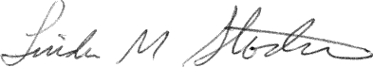
Secretary

