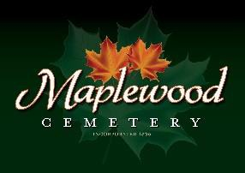

Maplewood Cemetery Association
24 Flinton Run
Churchville, NY 14428
Maplewood Cemetery Association

Quarterly Board Meeting
December 4, 2024
- President John Hatch brought the Directors Quarterly meeting to order.
Secretary’s Report: The Q3 meeting minutes were read by George. Motion by Scott to approve, seconded by Elizabeth and approved.

Treasurer’s Business Report: Gary’s Business Report 4th Quarter 2024. A motion to accept was made by Carol seconded by George and approved.

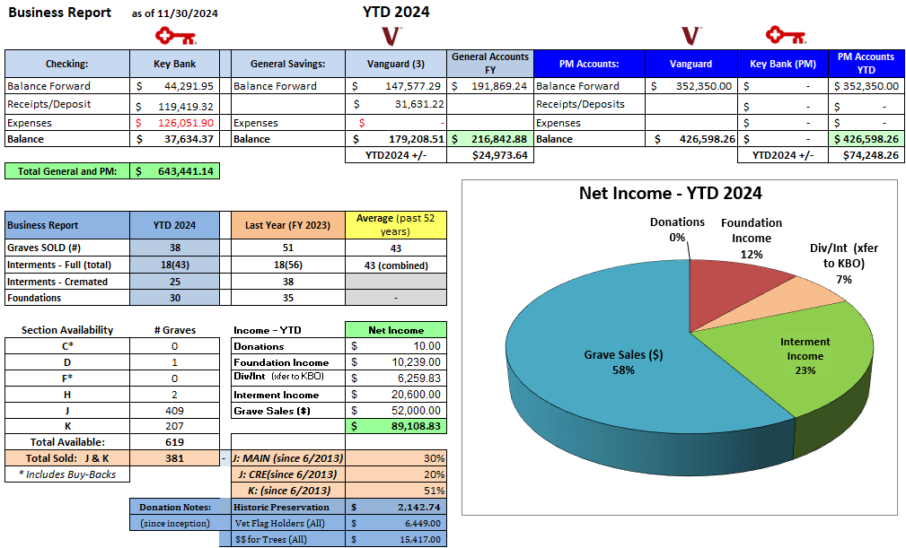

Finance Report: George reported:
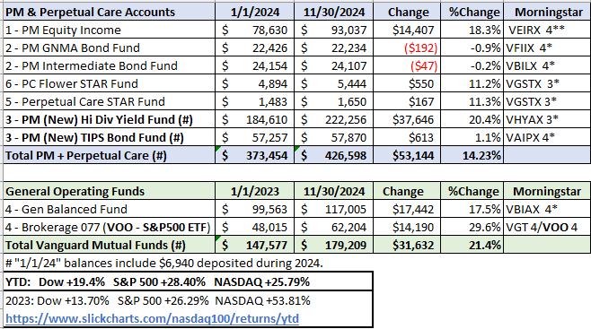

Sunshine Committee: Carol reported nothing.

Superintendent’s Report: It’s been a good year. Removed part of a berm to make way for a parking pad near the shed. The Town has not approved the pad yet. Bees were removed from the diggings area. Foxes continue to try for a new den but so far have not. Elizabeth suggested the DEC will come and trap them. The new mower is working well. A cable broke and was fixed. New tires installed caused the deck to be at different heights. The old mower’s engine is periodically not running right. Mark suggests we replace the lifters for an estimated $750. The driveway needs to be sealed next year.

Grounds Report: The berms will be removed by middle road next year and the tree mulched stopped reducing Chris Schaffer’s spring cleanup charges.

Website: The WordPress-based customer website continues to add features, links and photos. The same MaplewoodCemetery.org website address will take you there. The internal website, MaplewoodCemetery.org/mwcadmin has been updated. All board members can access this site without a password.

Database: It continues to be updated locally and uploaded to the MaplewoodCemetery.org/mwcadmin site.

Old Business:
- We are waiting for the Town to cut down the 2 dying trees. Once all the leaves are down, we will call them.
- The 3 new signs have been installed. Thanks to Scout Zach Ellis and his Eagle Project volunteers!
- The board needs to continue addressing the succession plans and officer roles and responsibilities as a follow-up to the May 11th Executive meeting. Training is available for the roles needed. Officer roles and responsibilities have been updated in the revised MWC Bylaws.
  - Board member training has been raised as a way to bring the necessary awareness of the cemetery’s needs and operations. The NYS Cemetery 101 training is available online or in person. Some familiarity with the MWCAdmin website should be included.
    - A motion for the board to attend training in the near future was made by Gary, seconded by Scott and approved.
  - Status: Rotation of the President: A motion was made by Margret to remove Scott from rotation, seconded by Hank and approved. The following positions should be excluded from the rotation along with Carol, Jim and Hank. Gary made a motion for John to continue as President next year, seconded by Melanie and was approved.
      - Secretary
      - Treasurer
      - Superintendent
      - Executive Director
    - Melanie will work on the nominations for the annual meeting. She will contact all individuals to make sure they are willing to serve.
  - The Audit Committee needs to be selected.
    - They will work with Gary on finance and account access.
    - Who is volunteering or being appointed to an audit committee? More effort is needed.
  - Treasurer: A new treasurer or vice treasurer is still an urgent need. All MWC business transactions are managed in this role. Training is available.
    - Someone needs to step up to be a vice treasurer to provide continuity and access to all financial operations and accounts.
  - Secretary: Who will step up to help as an assistant secretary?

New Business:
- A new ‘Sync-up’ meeting has been initiated. The ‘Key-3’ directors, John, Scott and Gary, now get together periodically between quarterly board meetings to catch up on all activities and issues. The next one is scheduled for January 17, 2025.
- Finance – Taxes and audits:
  - Employee’s W2 forms will be sent via Workforce in January 2025. Print and submit with your taxes
  - Vendor’s 1099 forms will be sent via email in January.
  - NYS Cemetery annual audit report will be completed in January.
  - IRS 990 tax-exempt report will be completed before the MWC Annual meeting.
  - 2024 PM report and Q4 PM payments will be made in January.
  - Any Mwc Audit committee participation is encouraged in any of these audit or PM reports.
  - No update on the anticipated NYS Cemetery Division audit. This may now include the years of 2017 through 2024.
- Annual Meeting preparations:
  - Ideas for increasing attendance
  - Topics for discussion
  - Nominating Committee completes election tasks.
  - Update on board training. Will be scheduled for late spring.

- New volunteers are looking for places where they can help.
  - More help is needed in some of the areas and projects listed below.
  - Projects: We need directors and volunteers to be project leaders.
    - Historic Preservation – New efforts to repair many of the historic monuments in Section A has started. The NYS Cemetery Division has a new investigator, Mike Catena, that is working with us to prepare a proposal for funding and repair. The repairs will not start until the Cemetery Division has approved that proposal. Work on any approved repairs will not start until spring 2025 at the earliest.
    - New Sections, lay out – A draft can be found at MwcAdmin. Comments are welcome.
    - Communications, website updates, email campaigns, document management
    - Recruitment, volunteers, board members
    - Cemetery Law, track updates and providing members with NYS guidance and compliance.
    - Assistant Secretary
    - Assistant Treasurer
    - Audit Committee
  - Scott suggested putting something in the Henrietta Highlights to get more volunteers.

The meeting was adjourned with a motion by Carol and seconded by Hank.

Next Meeting – The next meeting, our annual and 1st Quarter meetings of 2025, is scheduled for
7PM Wednesday March 5th. At the Henrietta Town Hall.

Directors and Officers Present: Carol Feasel, Gary and Linda Stockmaster, Margaret Hayes, George Zornow, Scott Nevol, Hank Wallace, John Hatch, Melanie Rajaphoumy Elizabeth Clarke and Sandra Ann Wilson

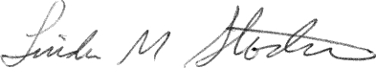
Secretary

