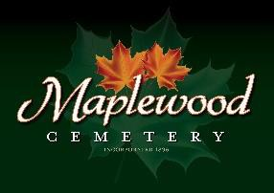

Maplewood Cemetery Association
24 Flinton Run
Churchville, NY 14428
Maplewood Cemetery Association

Quarterly Board Meeting
September 4, 2024
- President John Hatch brought the Directors Quarterly meeting to order. Welcome to our guests and new volunteers!
- Eagle Scout candidate Zach Ellis will start us off with a project update presentation to replace our dilapidated 'Rules' signs and add a new one in Section J. A motion to accept the project was made and approved.

Secretary’s Report: The Q2 meeting minutes were read by George. Motion by Jim to approve, seconded by Mark and approved.

Treasurer’s Business Report: Gary’s Business Report 3rd Quarter 2024. A motion to accept was made by Scott seconded by Hank and approved.
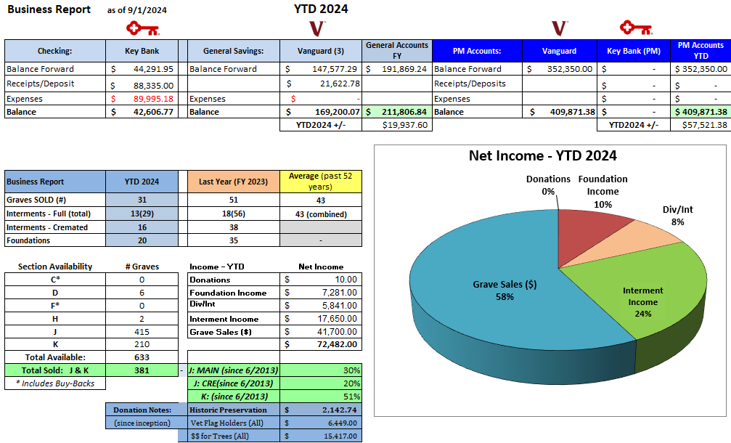
Finance Report: George reported:
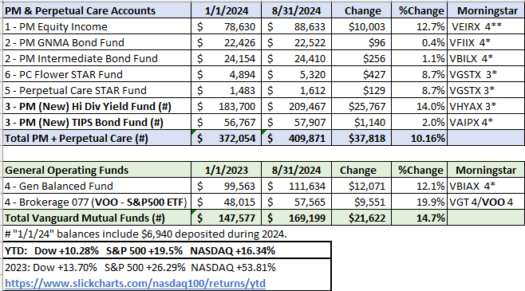

Sunshine Committee: Carol reported that Shirley Miller a former board member fell and broke her hip.

Superintendent’s Report: Foxes had a den in section A and Scott put a fence across, and covered with dirt and seems to be working. Scott went to the NYS Cemetery training and learned a few things that he shared. They are willing to come to us to conduct the training for the board. The new mower is working great. A couple of Maples are dying, and we need to have someone get us a quote for trimming or removing. An Arborist is needed to look at the maple trees on the east hill. Birchcrest, Flower City, or the Town of Henrietta were mentioned. There are ground bees in the diggings area that need to be removed. New tires were purchased and installed on the older Ferris. C& B Mower is now DT Mower in Lima. A Tree in section C needs trimming by a tree company.

Grounds Report: none

Website: The WordPress-based customer website continues to add features, links and photos. The same MaplewoodCemetery.org website address will take you there. The internal website, MaplewoodCemetery.org/mwcadmin has been updated. All board members can access this site without a password.

Database: It continues to be updated locally and uploaded to the MaplewoodCemetery.org/mwcadmin site.

Old Business:
- Gary reviewed his roadmap to retirement plans. An Executive meeting was held on May 11th to address succession plans and officer roles and responsibilities. Some progress has been made. More is needed.
- The MWC Bylaws committee has finalized a revised Bylaws document for approval. The proposal was emailed to all board members on August 18, 2024, requesting a review and comments. Thanks to the Bylaws committee!
  - A motion to accept was made to approve the Bylaws by Gary seconded by Scott and approved.
- Gary thanked Scott for all his hard work helping with sales and phone calls. (169 VM calls thru August 31st.)
- Mark and Scott purchased a new jack hammer. As approved in June.
- Mark Feasel purchased and took possession of a new 60” Ferris mower, and traded in the 48” Scag 2017 mower, as approved in the June meeting.

New Business:
- The board needs to continue addressing the succession plans and officer roles and responsibilities as a follow-up to the May 11th Executive meeting. Training is available for the roles needed. Officer roles and responsibilities have been updated in the revised MWC Bylaws.
  - Board member training has been raised as a way to bring needed awareness of the cemetery’s needs and operations. The NYS Cemetery 101 training is available online or in person. Some familiarity with the MWCAdmin website should be included.
    - A motion for the board to attend training in the near future was made by Gary seconded by Scott and approved.
  - Rotation of the President: This rotation list should be updated and agreed upon. The exclusions should also be noted and agreed upon. The following officer positions should be excluded from the rotation:
    - Secretary
    - Treasurer
    - Superintendent
    - Executive Director
    - Jim will work to create a motion for rotation and term limits.
  - Executive Director: The revised Bylaws added a new officer position, Executive Director. A motion was made by Linda and seconded by Mark to appoint Gary and it was approved.

  - Audit Committee needs to be selected.
    - They will work with Gary for finance and account access.
    - Who is volunteering or being appointed to an audit committee? More effort needed.
  - Treasurer: A new treasurer or vice treasurer is still an urgent need. All MWC business transactions are managed in this role. Training is available.
    - Someone needs to step up to be a vice treasurer to provide continuity and access to all financial operations and accounts.
  - Secretary: Cindy Dalton will not be able to help Linda on meeting minutes.
    - Who will step up to help as assistant secretary?
    - A NYS compliance issue was identified and resolved. NYS does not allow the Secretary to sign the deed. The President and Treasurer, or their assistants, are authorized to sign the deeds. The change has been made.
  - CPAs and Bookkeepers; Gary met with a few accounting firms regarding the possibility of them providing the financial support functions and reporting for the Treasurer. None are willing to accept the responsibilities and liabilities of transactional access to our accounts. The cost of non-transactional bookkeeping and CPA audits could be prohibitive.
  - Accounting Requirements: Some good news was revealed in my meeting with a CPA regarding the NYS Cemetery Division classification of small, medium and large cemeteries. The previous ruling that any NYS cemetery with assets over $400k was considered a medium cemetery and REQUIRED a CPA audit. This ruling has been overturned citing the undue hardship imposed on these medium cemeteries.
  - Cemetery visited by new NYS Cemetery Division investigator, Mile Catena. All NYS cemeteries are subject to be reviewed periodically by a NYS investigator. The check list of requirements for the operation of the cemetery was completed with no violations found.

- New volunteers are looking for where they can help.
  - A motion was made by Linda to nominate Elizabeth to the board seconded by Gary and approved. Welcome aboard!
  - More help is needed to some of the areas and projects listed below.
  - Projects: We need directors and volunteers to be project leaders.
    - Historic Preservation – New efforts to repair many of the historic monuments in Section A has started. The NYS Cemetery Division has a new investigator, Mike Catena, that is working with us to prepare a proposal for funding and repair. The repairs will not start until the Cemetery Division has approved that proposal. Work on any approved repairs will not start until spring 2025.
    - New Sections, lay out – A draft can be found at MwcAdmin. Comments are welcome.
    - Communications, website updates, email campaigns, document management
    - Recruitment, volunteers, board members
    - Cemetery Law, track updates and provide members with NYS guidance and compliance.
    - Assistant Secretary
    - Assistant Treasurer
    - Audit Committee

The meeting was adjourned with a motion by Ray and seconded by George

Next Meeting – The next meeting, our 4th Quarter meeting of 2024, is scheduled for
7PM Wednesday December 4th. At the Henrietta Town Hall.

Directors and Officers Present: Carol & Ray Feasel, Gary and Linda Stockmaster, Mark Feasel, Margaret Hayes, Jim Comstock, George Zornow, Scott Nevol, Hank Wallace, John Hatch, Melanie Rajaphoumy Elizabeth Clarke and Sandra Ann Wilson

Thanks to our Guest: Zachary Ellis
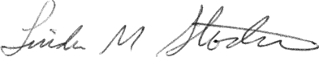
Secretary

