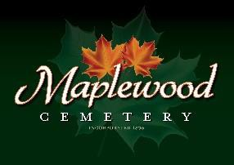

Maplewood Cemetery Association
24 Flinton Run
Churchville, NY 14428
Maplewood Cemetery Association

Quarterly Board Meeting
June 5, 2024
President John Hatch brought the Directors Quarterly meeting to order. Welcome to our guests and new volunteers!

Secretary’s Report: The Q1 meeting minutes were read. Motion by __________ to approved, seconded by _________ and approved.

Treasurer’s Business Report: Gary’s Business Report 2nd Quarter 2024. A motion to accept was made by _________ seconded by __________ and approved.
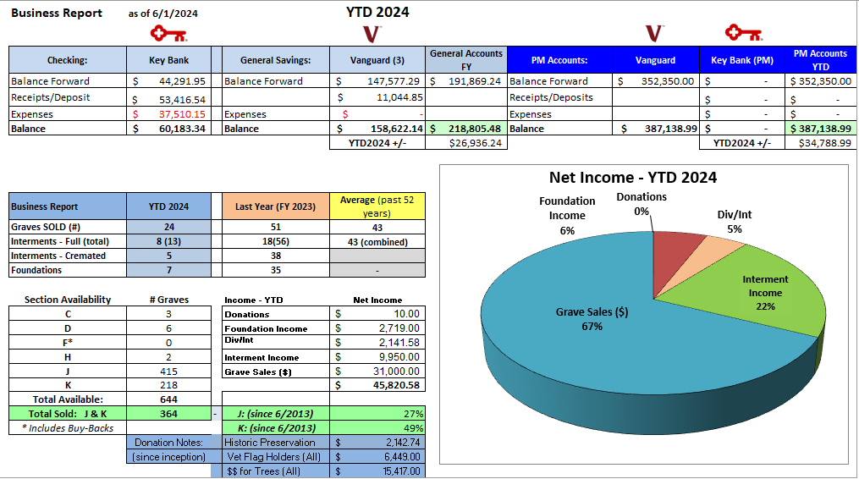

Finance Report: George reported:
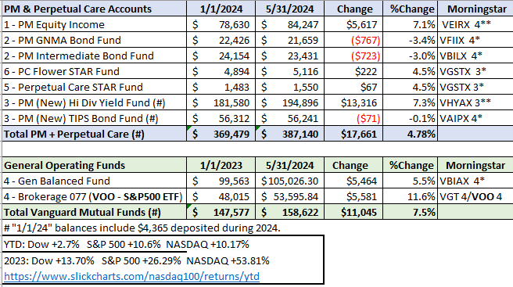

Sunshine Committee: A $100 contribution was sent to Henrietta United Church of Christ in memory of Phyllis McHargue.

Superintendent’s Report: .

Grounds Report:

Website: The new WordPress-based customer website continues to add features. The same MaplewoodCemetery.org website address will take you there. The internal website, MaplewoodCemetery.org/mwcadmin has been updated.

Database: It continues to be updated locally and uploaded to the MaplewoodCemetery.org/mwcadmin site.

Old Business:
- Gary presented his roadmap to retirement plans. An Executive meeting was held on May 11th to address succession plans and officer roles and responsibilities.
- Gary thanked Scott for all his hard work helping with sales and phone calls. (104 VM calls thru May 31st.)
- Mark and Scott would like to purchase a new jack hammer. A motion was made by Hank and seconded by Mark and approved $500 to spend.

New Business:
- Need to seriously address succession plans and officer roles and responsibilities as a follow-up to the May 11th Executive meeting.
  - Determine key leadership positions.
  - Update needed to MWC Bylaws
    - The constitution of an organization contains the fundamental principles which govern its operation. The bylaws establish the specific rules of guidance by which the group is to function.
  - Audit Committee needs to be selected.
    - Audit leader needs to be selected and training for finance and account access.

- New volunteers are looking for where they can help. Suggestions and training?
- Projects: We need directors and volunteers to be project leaders.
  - Historic Preservation
  - Lead MWC Bylaws revisions
  - Cemetery sign replacement
  - New Sections, lay out
  - Communications
  - Recruitment
  - Cemetery Law

The meeting was adjourned with a motion by ____________ and seconded by _____________.

Next Meeting – The next meeting, our 3rd Quarter meeting of 2024, is scheduled for 7PM Wednesday September 4th. At the MWC Shed. BYO-Chair

Directors and Officers Present: Ray and Carol Feasel, Gary and Linda Stockmaster, Mark Feasel, Margaret Hayes, George Zornow, Scott Nevol, Hank Wallace, John Hatch, Melanie Rajaphoumy and Sandra Ann Wilson

Guests:

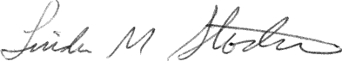
Secretary

