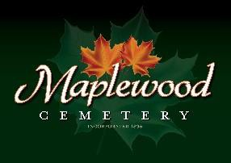

Maplewood Cemetery Association
24 Flinton Run
Churchville, NY 14428
Maplewood Cemetery Association

Quarterly Board Meeting
June 5, 2024
President John Hatch brought the Directors Quarterly meeting to order. Welcome to our guests and new volunteers!

Secretary’s Report: The Q1 meeting minutes were read by George. Motion by Mark to approved, seconded by Carol and approved.

Treasurer’s Business Report: Gary’s Business Report 2nd Quarter 2024. A motion to accept was made by George seconded by Hank and approved.
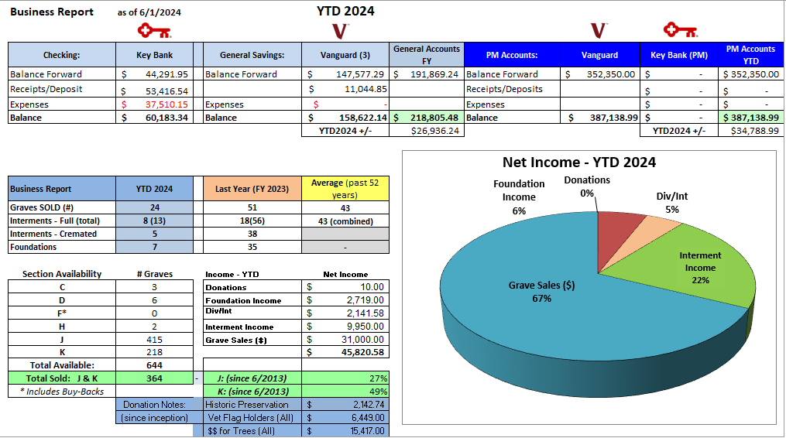

Finance Report: George reported:
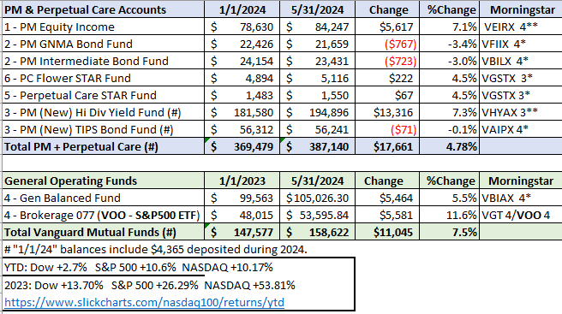

Sunshine Committee: Carol reported receiving a thank-you card from the family of Phyllis McHargue and another from the United Church of Christ for the $100 donation made in Phyllis’s name.
Phyllis McHargue was the much-respected past Secretary of Maplewood Cemetery.

Superintendent’s Report: Carol reported that mowing had started early this year (April) and continues. Mark and Scott are doing a great job. John Hatch asked about Scott’s work. Carol thanked Scott for his hard work with taking on sales.

Grounds Report: Mark reported for Grounds. He gave information on the condition of many dead limbs on the tops of trees. Need a tree company to do this. One large tree was taken down and removed. Gary is also concerned about the lack of growth of the maple trees on the east hill. Mark also remarked that sealing of portions of the driveway should be looked into. He also explained that driveways #4 intersecting with the main road has a “dip.” Mark is going to ask Craig to help fix an area in the driveway. Gary reports that there is now a work maintenance agreement with the Town of Henrietta to help with work like this. After the big storm, it took 3 full gator loads to remove the downed branches. Mark and Scott report that the jack hammer was purchased and picked up.

Website: The new WordPress-based customer website continues to add features. The same MaplewoodCemetery.org website address will take you there. The internal website, MaplewoodCemetery.org/mwcadmin has been updated. Scott said the site is very valuable to him. He can be remote and sell graves and answer questions.

Database: It continues to be updated locally and uploaded to the MaplewoodCemetery.org/mwcadmin site.

Old Business:
- Gary presented his roadmap to retirement plans. An Executive meeting was held on May 11th to address succession plans and officer roles and responsibilities.
- Gary thanked Scott for all his hard work helping with sales and phone calls. (104 VM calls thru May 31st.)
- Mark and Scott would like to purchase a new jack hammer. A motion was made by Hank and seconded by Mark and approved $500 to spend. This was purchased.

New Business:
- Need to seriously address succession plans and officer roles and responsibilities as a follow-up to the May 11th Executive meeting. Training is available for the roles needed. MWC Bylaws need to be revised.
  - Determine key leadership positions. I presented 3 key positions at the exec meeting:
    - President (or chairman) of the Board of Directors
    - Executive Director or Business Manager of all business functions
    - Superintendent of grounds operations
  - Updates needed to MWC Bylaws: Melanie and Elizabeth will work on updated the bylaws
    - The bylaws establish the specific rules of guidance by which the group is to function.
  - Audit Committee needs to be selected.
    - Jim Comstock said he would be willing to be the Audit leader. He will work with Gary for finance and account access.
  - Treasurer: A new treasurer or vice treasurer is still an urgent need. All MWC business transactions are managed in this role. Training is available.
  - Sales: Susan will work with Gary and Scott to help in the sales area.
  - Secretary: Cindy Dalton is working with Linda on meeting minutes.
- New volunteers are looking for where they can help.
  - More help is needed to some of the areas and projects listed below.
- Projects: We need directors and volunteers to be project leaders.
  - Historic Preservation - George and maybe Susan
  - Lead MWC Bylaws revisions – Melanie & Eilzabeth
  - Cemetery sign replacement Cindy has created a draft of the new design and Zach Ellis will conduct an Eagle project to install the signs.
  - New Sections, lay out – A draft can be found at MwcAdmin Comments are welcome.
  - Communications
  - Recruitment
  - Cemetery Law

Leadership Position Changed: Superintendent - Carol has worked since 1981 and expressed her love for MWC. Her labor and contributions to MWC are greatly appreciated by all board Members. John made a motion to make Scott the new superintendent and move Carol to a director effective July 1 seconded by Mark and approved.

Closing Business: Mark Feasel asking the Board for approval to sell or trade a virtually unused 48” Scag 2017 mower to purchase a 60” Ferris mower, estimating a need of $8000. Mark will investigate possibilities and notify John of his findings if circumstances are different. Jim made the motion seconded by Hank and it was approved.

The meeting was adjourned with a motion by Linda and seconded by George.

Next Meeting – The next meeting, our 3rd Quarter meeting of 2024, is scheduled for
7PM Wednesday September 4th. At the MWC Shed. BYO-Chair

Directors and Officers Present: Carol Feasel, Gary and Linda Stockmaster, Mark Feasel, Margaret Hayes, Jim Comstock, George Zornow, Scott Nevol, Hank Wallace, John Hatch, Melanie Rajaphoumy and Sandra Ann Wilson

Thanks to our Guests: Susan Mack, Elizabeth Clarke (attorney), Cindy Dalton and Alison St. James.
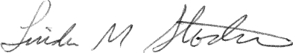
Secretary

