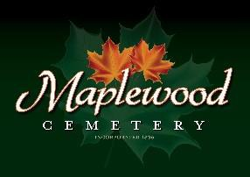

Maplewood Cemetery Association
24 Flinton Run
Churchville, NY 14428
Maplewood Cemetery Association

Quarterly Board Meeting
March 6, 2024
President George Zornow brought the Directors Quarterly meeting to order.

Secretary’s Report: Mark made a motion seconded by Scott to not read the minutes of the last Quarterly report and it was approved.

Treasurer’s Business Report: Gary’s Business Report – 1st (YTD) Quarter 2024. A motion to accept was made by Mark, seconded by Scott and approved.
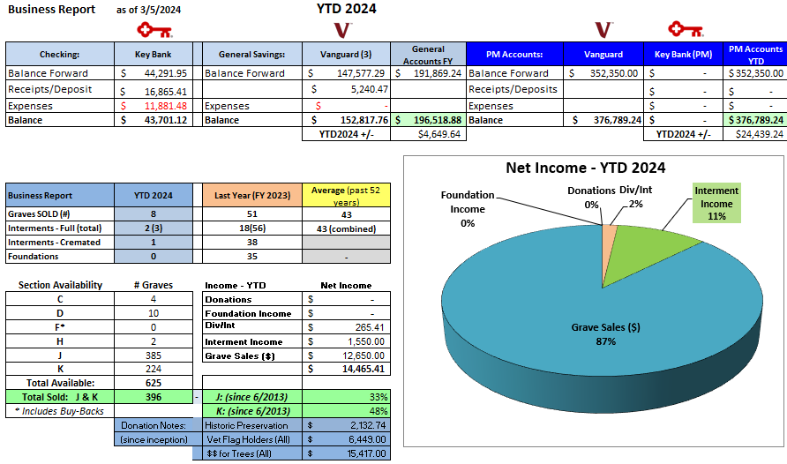

Finance Report: George reported:
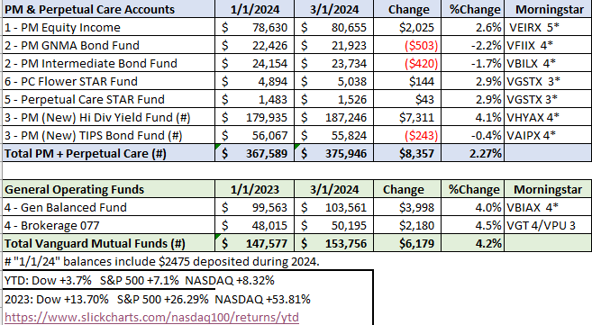

Sunshine Committee: A $100 contribution was sent to Honor Flight in memory of Paul Macauley.

Superintendent’s Report: Everything is looking good.

Grounds Report:

Website: The new WordPress-based customer website continues to add features. The same MaplewoodCemetery.org website address will take you there. The internal website, MaplewoodCemetery.org/mwcadmin has been updated.

Database: It continues to be updated locally and uploaded to the MaplewoodCemetery.org/mwcadmin site.

Old Business:
- Gary presented his roadmap to retirement plans.
- Gary thanked Scott for all his hard work helping with sales and phone calls.
- NYS has postponed their planned 8-year audit with us, initially scheduled for February 8, 2024. No new date set yet.
- We need to form an Audit committee to determine who, when and what to audit. Melanie, George, and Hank will look into it after the NYS audit.
- Gary reviewed the change to our eBusiness plans.
    - This includes direct payroll deposits, e-invoices, e-payments. (Via QuickBooks Online, QBO)
    - E-payments include bills and receiving payments.
- Gary is looking for support for – Historic Preservation Fund. We have historic monuments and foundations that need repair and have been beyond our budgeting abilities.

New Business:
Mark and Scott would like to purchase a new jack hammer. A motion was made by Hank and seconded by Mark and approved $500 to spend.

The meeting was adjourned with a motion by Ray and seconded by Gary.

Next Meeting – The next meeting, our 2nd Quarter meeting of 2024, is scheduled for 7PM Wednesday June 5th. At the MWC Shed. BYO-Chair

Directors and Officers Present: Ray and Carol Feasel, Gary and Linda Stockmaster, Mark Feasel, Margaret Hayes, George Zornow, Scott Nevol, Hank Wallace, John Hatch, Melanie Rajaphoumy and Sandra Ann Wilson

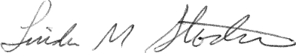
Secretary

