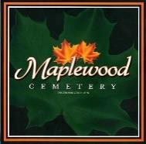
Maplewood Cemetery Association

150 Middle Road
Henrietta, NY 14467 127th Annual Meeting (Reviewing 2023)

Held on March 6, 2024, at Henrietta Town Hall

President George Zornow called the Annual Meeting to order and welcomes guests. Introductions, then we will start our normal meeting (in Presentation mode) and then show a brief history of Maplewood Cemetery and have an open forum for Q&A.
Secretary Report: A motion was made by John to not read the minutes of the last meeting seconded by Scott and approved.

Treasurer Report: Gary provided a summary of the FY 2023 financial position in the Treasurer’s business report.

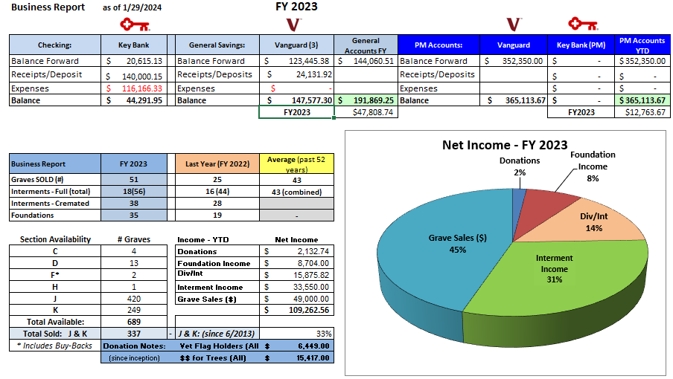

A motion was made by Mark and seconded by Scott to approve the treasurer’s FY 2023 business report.

Finances: George presented the FY 2023 finance report. 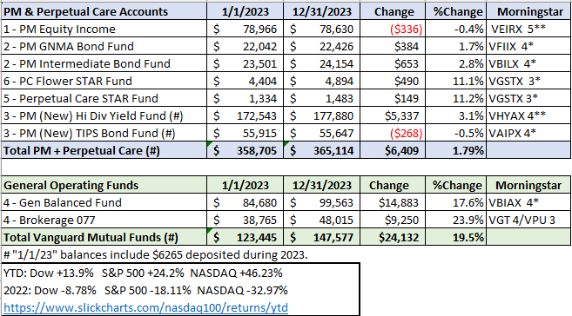

Superintendent’s Report:
Carol reported we were busy last year.

The Grounds Report:

Gary was able to get assistance from the Town in a new Cemetery Maintenance Assistance Agreement. The Town has agreed to plow, salt and trim trees were necessary. They also have a sign shop which may be able to help replace the old green signs. The drainage system is working well in Section J.

Sunshine Committee:
Carol sent a donation to the Honor Flight Rochester in honor of Paul Macauley.

Old Business: None

Nominating:

George read the list of directors whose terms are ending, Jim Comstock, Mark Feasel, Sandra Ann Wilson, Linda Stockmaster,
2– Open Positions.
The new officer nominations are President: John Hatch, 1st Vice – Scott Nevol, 2nd Vice – Hank Wallace.
Superintendent - Carol Feasel, Secretary - Linda Stockmaster and Treasurer (Interim) - Gary Stockmaster

Note: The board still has two openings. We should look for 1 or 2 possible new candidates for director positions. Website: Gary stated that we now have 2 websites, the internal MwcAdmin continues to be well used. The public website has been heavily accessed and has new features.
Database: The database continues to be updated.
Open Forum: Welcome visitors:

Gary has a presentation and display of the history of MWC,

John made a motion to adjourn the annual meeting with a second by Hank and all approved.

Next Annual Meeting – Wednesday, March 6th, 2025 (subject to change)

Directors and Officers Present:
Ray and Carol Feasel, Gary and Linda Stockmaster, Mark Feasel, Margaret Hayes, George Zornow,
Scott Nevol, Melanie Rajaphoumy and Sandra Ann Wilson.

We had the following visitors: Anthony Kemmer, Cynthia Grady, and Don Wallace.

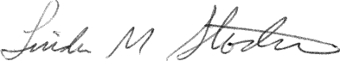
Secretary

