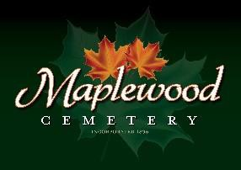

Maplewood Cemetery Association
24 Flinton Run
Churchville, NY 14428
Maplewood Cemetery Association

Quarterly Board Report
December 5, 2023
This is the December 2023 (Q4-YTD) Quarterly Board Report in place of a physical meeting.

Treasurer’s Business Report: Gary’s Business Report 4th Quarter (YTD) 2023. Despite the gloomy forecast based on last year’s performance we will end with positive results. Cremations outpaced full interments by ~2 to 1. Grave sales closed with a big finish. There may still be some financial activity the remainder of this month that will be reported at the annual meeting.

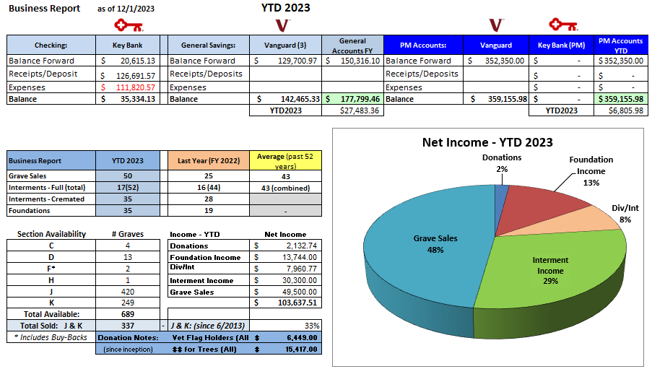

Forecast & Actuals: Update (expenses were updated on 8/2023, Actuals are current)

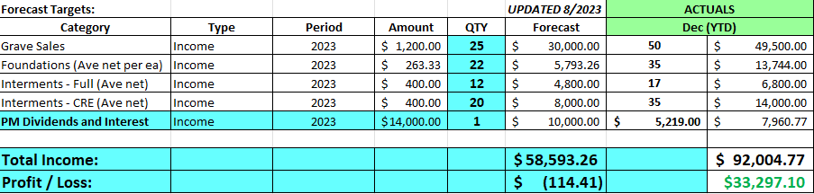

Finance Report: George reported that we had a negative return on our PM accounts, but it was better than last year’s results. The market was just starting to move up late this quarter, The funds may improve by the close of this year.
The General Operating fund results continue to be very positive.

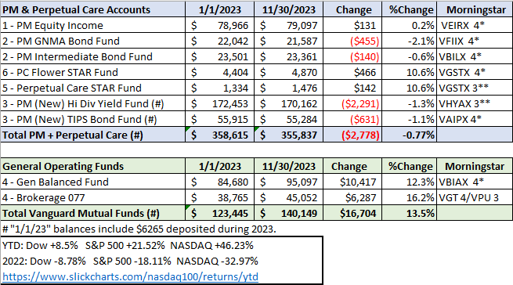

Gary’s Comments:
- Thanks go out to Scott for volunteering to take on the sales tasks. That was my number 1 concern.
- I have not heard much of anything from most of the board. No suggestions, no additional support….
- Yes, I still plan to retire, but with Scott’s support I will stay on through the Annual meeting.
- I have a meeting with Henrietta Supervisor Schultz next week to discuss the possibilities of support from the Town for a variety of reasons, such as road salting in a dangerous icing condition or major tree clearing situations. Other topics will be discussed, and I will update you.
- Please review the ‘Emergency Meeting’ email that was sent out on Nov. 15th.
  - There is more work to be done to address the remaining issues.
- Please prepare for the annual meeting.
  - What changes are needed based on current events?
  - Do we need to review our pricing for cremations based on the overwhelming increase in demand?
  - Is EMAIL the best way to communicate with you? We are all inundated with email messages, what can we do better?
- I wish everyone a Merry Christmas and a Happy New Year!

The 2024 Annual meeting, reviewing FY 2023, and the 1st Quarter 2024 board meeting will be held March 6th, 2024, 7 – 9 PM @ Henrietta Town Hall.
Reminders and any schedule changes will be sent out as usual.

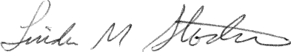
________________________________
Secretary

