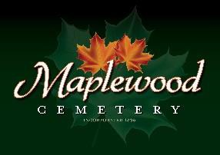

Maplewood Cemetery Association
24 Flinton Run
Churchville, NY 14428
Maplewood Cemetery Association

Quarterly Board Meeting
September 6, 2023
President George Zornow brought the Directors Quarterly meeting to order.
Matt Miller from Miller’s Funeral Home addressed the board. He handed out a price list of the various cemeteries. Our cemetery is heads above others for our maintenance. We have little junk around the graves. Our prices are good. Last year they saw cremations go over 50%, He thinks the interment charge should be the same price. If funeral home is not involved other cemeteries charge extra to process the paperwork. Suggested a bigger table for cremation ceremonies. Urn vaults are not required.
Secretary’s Report: Linda read the minutes of the 2nd Quarterly report. A motion to approve was made by Mark, seconded by Jim and approved.

Treasurer’s Business Report: Gary’s Business Report – 3rd Quarter 2023. A motion to accept was made by Carol, seconded by Scott and approved.
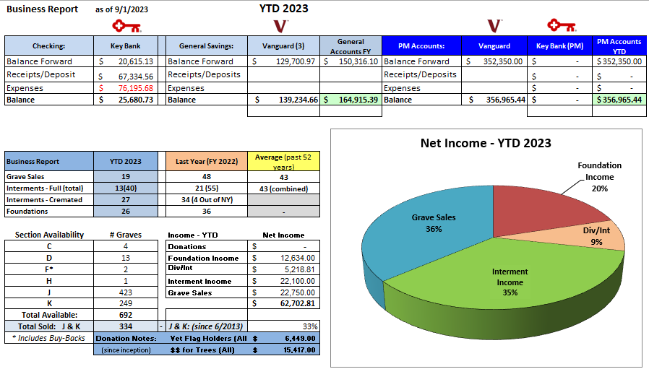

Gary updated the YTD expenses and income and presented our status. It costs about $58,593 annually to ‘run’ the cemetery. We may make the ‘break even’ point soon. No positive margin seen for projects or costly repairs.

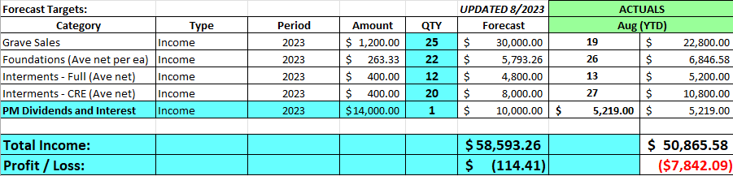

Finance Report: George reported:
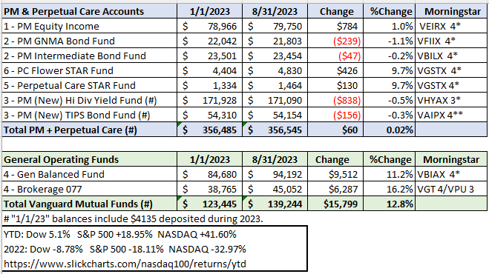

Sunshine Committee: Flowers sent to Frank Martin’s funeral, Joe Martin’s dad. Donated $100 to Chili Post for Larry Rath.

Superintendent’s Report: Everything is looking good.

Grounds Report: A maple tree on the back road looks bad. Mark said there are hanging limbs in D & F sections. There was talk about renting equipment and Mark and Scott will take care of it. Mark is concerned about wooden crosses in H and F. Should place a notice to remove. Scott has a problem with gardens on the wrong side. One plant Japanese lantern is getting too large.

Website: The new WordPress-based customer website continues to add features. Monument photos and search capability have been added. Over 123 people have accessed the site this month. The same MaplewoodCemetery.org website address will take you there. The internal website, MaplewoodCemetery.org/mwcadmin has been updated.

Database: It continues to be updated locally and uploaded to the MaplewoodCemetery.org/mwcadmin site.

Old Business:

We should begin planning the next phase of expansion in the next 5 years.
- Gary presented an update of his vision of moving to a more cloud-based operation for additional people to access.
  - It was noted that most of the applications we use to operate the business and operations functions of the cemetery are already cloud-based. The MaplewoodCemetery.org/mwcadmin site should be our business reference vs. printed listings. Things change too fast to keep printed listings up to date.
  - QuickBooks, used for financial management, has been migrated to the ‘On-line’ version from the ‘Desktop’ version. Payroll has been moved to direct-deposit from check-based.
  - Shafer Landscape is the 1st contractor to transact electronically vs. paper-based invoices and checks.

New Business:
  - NYS Division of Cemeteries, meeting in Canandaigua. Attended by Gary & Linda
    - New Auditor, Sarah Levin, and new Investigator, Mike Catena. Both out of Buffalo.
    - The audit process should be a verification process, not an inquisition. Our last audit was in 2016. NYS may want a 7-year audit with us. No date set yet.
      - We need to form an Audit committee to determine who, when and what to audit. Melanie, George, and Hank will look into it.
    - Updates and procedures were presented. The Q&A session was helpful and raised some questions about our Rules & Regulations and operations.
    - NYS states that almost anything not defined in the Rules & Regulations is by default ‘allowed’.
      - Who will review the Rules and Regulations?
    - NYS director stated that all transactions need to be channeled through 1 bank account and that paper checks are the preferred payment method. We do use 1 bank account.
    - The NYS Cemetery Law and Division guidelines on grave ownership and inheritance were presented.
  - Motion: Gary made a motion to approve the change to the proposed eBusiness plans.
    - This includes direct payroll deposits, e-invoices, e-payments. (Via QuickBooks Online, QBO)
    - E-payments include bills and receiving payments.
    - Motion by Gary, seconded by Ray.
  - Motion: Gary made a motion to create a new fundraiser – Historic Preservation Fund. We have historic monuments and foundations that need repair and have been beyond our budgeting abilities. The current target estimate for the fund is $10,000. QBO has customer and vendor email lists that can be used.
  - Motion by Gary, seconded by Jim.
  - Jim suggested we also ask the NYS Assembly representative Harry Bronson for funding. Gary will put together some pictures and pricing estimates.

The meeting was adjourned with a motion by Carol and seconded by Scott.

Next Meeting – The next meeting, our 4th Quarter meeting of 2023, is scheduled for Wednesday December 6th. Plan to make this a Business report, not a physical meeting. The report will be sent out via email.

Annual Meeting: Mark your calendars, Wednesday March 6th, 2024, at the Henrietta Town Hall.

Directors and Officers Present: Ray and Carol Feasel, Gary and Linda Stockmaster, Mark Feasel, Margaret Hayes, George Zornow, Scott Nevol, Jim Comstock, Hank Wallace, John Hatch, Melanie Rajaphoumy and Sandra Ann Wilson

Guest: Matt Miller, Miller Funeral Home

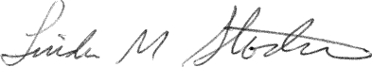
Secretary

