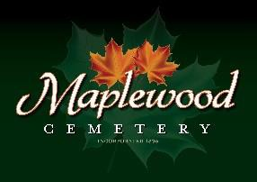

Maplewood Cemetery Association
24 Flinton Run
Churchville, NY 14428
Maplewood Cemetery Association

Quarterly Board Meeting
June 7, 2023
President George Zornow brought the Directors Quarterly meeting to order.
Secretary’s Report: Linda read the minutes of the 1st Quarterly report. A motion to approve was made by John, seconded by Jim, and approved.

Treasurer’s Business Report: Gary’s Business Report – 2nd Quarter 2023. A motion to accept was made by John, seconded by Carol and approved.
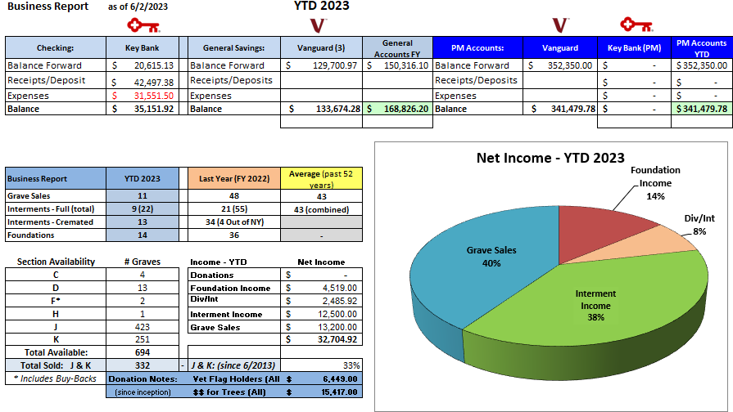

Gary updated the YTD expenses and income and presented our status. It costs about $56,633 to ‘run’ the cemetery with a profit of $2,425. (based on the forecast presented at the 1st Quarter meeting).

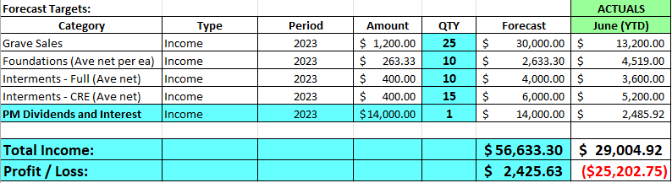

Finance Report: George reported:
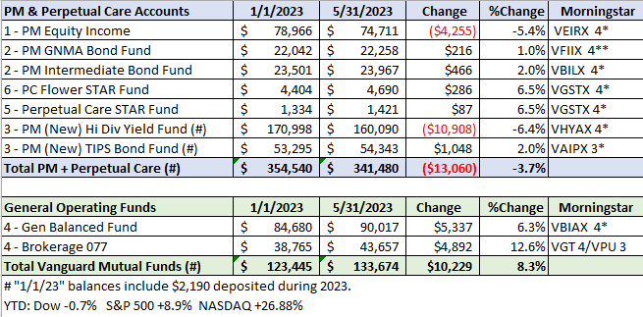

Sunshine Committee: Nothing to report.

Superintendent’s Report: 13 cremations were caught up from winter. Carol anticipates more full interments. She has been very busy. Several great comments about how nice the cemetery looks.

Grounds Report: A tree has been replaced in the center of sections J&K. A new Cleveland Select Pear has been added to be consistent with the other trees in the center row. A maple tree on the back road looks bad. Mark said there are hanging limbs in D & F sections. There was talk about renting equipment and Mark and Scott will take care of it.

Website: Gary has created a new WordPress-based customer website. The same MaplewoodCemetery.org website address will take you there. The internal website, MaplewoodCemetery.org/mwcadmin has been updated.

Database: It continues to be updated locally and uploaded to the MaplewoodCemetery.org/mwcadmin site.

Old Business:

Anniversary time! Sections J&K have been open for 10 years, tomorrow… A YouTube video is available showing the development of these sections, the east hill, the south area and our roads.
- Note: The Bylaws revisions have not been completed. No meeting schedule has been set.
- Gary presented an update of his vision of moving to a more cloud-based operation for additional people to access.
  - It was noted that most of the applications we use to operate the business and operations functions of the cemetery are already cloud-based. The MaplewoodCemetery.org/mwcadmin site should be our business reference vs. printed listings. Things change too fast to keep printed listings up to date.
  - QuickBooks, used for financial management, has been migrated to the ‘On-line’ version from the ‘Desktop’ version. Payroll has been moved to direct-deposit from check-based.
  - Shafer Landscape is the 1st contractor to transact electronically vs. paper-based invoices and checks.

New Business:
  - Security review. How to respond to issues that are identified on Reolink. It was decided that we should call 911 if a serious problem was seen.
  - We should begin planning the next phase of expansion in the next 5 years.
  - Two plaques will be installed to recognize Sarah and Owen Ellis for their Eagle Projects.

The meeting was adjourned with a motion by Carol and seconded by Ray.

Next Meeting – The next meeting, our 3rd Quarter meeting of 2023, is scheduled for Wednesday September 6th @ 7 PM at the shed. Meeting reminders will be sent out as usual.

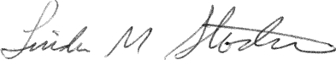
Directors and Officers Present Ray and Carol Feasel, Gary and Linda Stockmaster, Mark Feasel, Margaret Hayes, George Zornow, Scott Nevol, Jim and Sue Comstock, and Sandra Ann Wilson

Secretary

