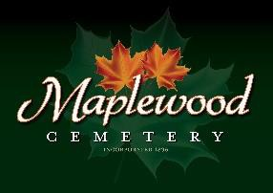

Maplewood Cemetery Association
24 Flinton Run
Churchville, NY 14428
Maplewood Cemetery Association

Quarterly Board Meeting
March 1, 2023
President Margaret Hayes brought the Directors Quarterly meeting to order.

Secretary’s Report: Linda read the minutes of the YTD 2023 Quarterly report. A motion to approve was made by George, seconded by Carol, and approved.

Treasurer’s Business Report: Gary’s Business Report – 1st Quarter 2023. A motion to accept was made by Scott seconded by Jim and approved. 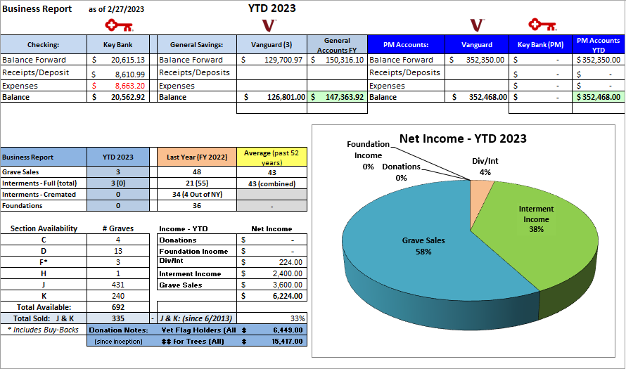

Gary reviewed the expenses and income and presented our future forecast. It cost about $56,633 to ‘run’ the cemetery with a profit of $2,425.

Finance Report: George reported 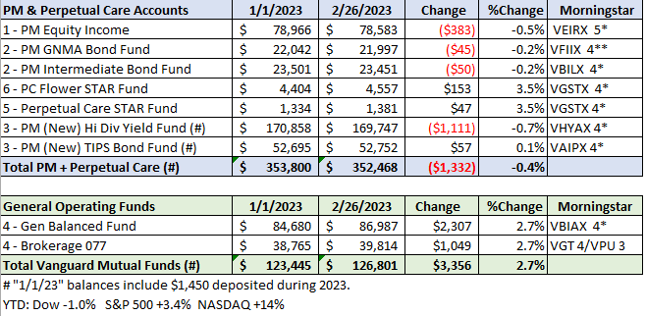

Sunshine Committee: Nothing to report.

Superintendent’s Report: We had a lot of snow, and it was hard to find grave markings.

Grounds Report:
- John Deere Tractor needs maintenance and a problem fixed.
- Changed the battery in the large mower.

Nominations:
- Carol Feasel, Margaret Hayes, and Scott Nevol were approved for another 3-year term as Board Directors.
- The following officers were approved for a 1-year term:
  - George Zornow – President
  - Sue Comstock – 1st VP
  - John Hatch – 2nd VP
  - Carol Feasel – Superintendent
  - Linda Stockmaster – Secretary
  - Gary Stockmaster - Treasurer
Website: Gary is working on a new website to make it easier to maintain.

Database: It continues to be updated.

Old Business:
- MWC By-Laws review. John recommends a committee of himself, Gary, Scott, George and Melanie, work on the Bylaws and present their findings at the annual meeting. Margaret should also be invited. Gary agreed to host at his house.
  - Note: The Bylaws have not been completed. No meeting schedule has been set.
- Some discussion was had about the salary we currently pay employees.
- Scott has agreed to work with Carol to learn what she does as superintendent.
- 2022 Sales and revenues are lower than anticipated.

New Business:
- An Executive Committee reviewing salaries agreed to include the Treasurer as a paid employee.
  - The annual salary was set at $5,100.
- Chris Shafer changed his gardening maintenance. Spring Cleanup to $1,150.
  - Includes: All ‘new’ trees with a mulch border. Remove leaves and debris, edge and mulch most gardens and tree beds in the spring. Price includes materials and labor. All work to be completed prior to Memorial Day.
- New contract with Cardinal Landscaping for shed berm, memorial garden. front garden and East hill garden is $5,200. A motion form Jim and seconded by Linda was approved for both.
- Gary presented his vision of moving to a more cloud-based operation for additional people to access.
  - It was noted that most of the applications we use to operate the business and operations functions of the cemetery are already cloud-based.
  - QuickBooks, used for financial management, has been migrated to the ‘On-line’ version from the ‘Desktop’ version. Payroll has been moved to direct-deposit from check-based.
  - Vendors are being encourage transact electronically vs. paper-based invoices and checks.

The meeting was adjourned with a motion from by George and seconded by Mark.

Next Meeting – The next meeting, 2nd Quarter meeting of 2023, is scheduled for Wednesday June 7th @ 7 PM at the shed. Meeting reminders will be sent out as usual.

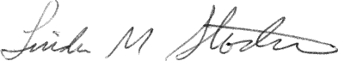
Directors and Officers Present Ray and Carol Feasel, Gary and Linda Stockmaster, Mark Feasel, Margaret Hayes, George Zornow, Scott Nevol, Jim Comstock, Melanie Rajaphoumy and Sandra Ann Wilson.
Secretary

