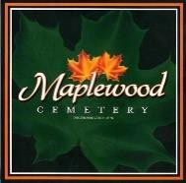
Maplewood Cemetery Association

150 Middle Road
Henrietta, NY 14467 126th Annual Meeting (Reviewing 2022)

Held on March 1, 2023, at Henrietta Town Hall

President Margaret Hayes called the Annual Meeting to order.

Secretary Report: The minutes of the last annual meeting of March 2022 were read by Linda Stockmaster. Mark made a motion to approve the minutes, seconded by Scott and approved.

Treasurer Report: Gary provided a summary of the financial position in the Treasurer’s business report.

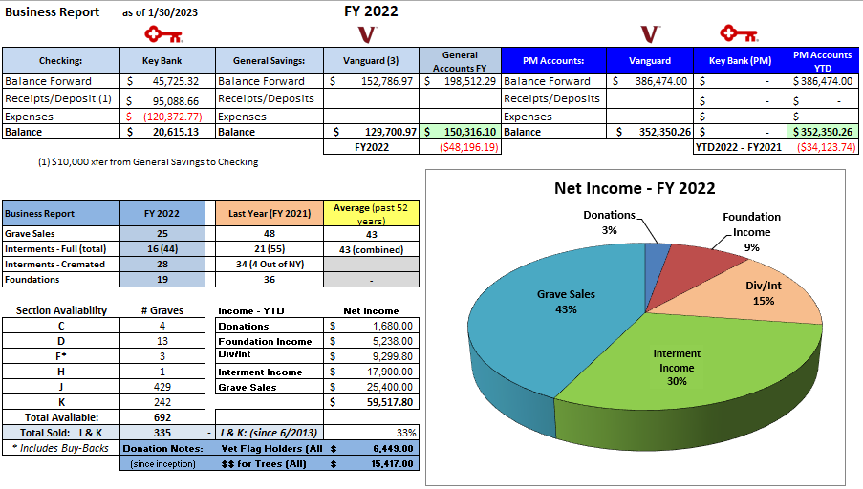

A motion was made by George and seconded by Carol to approve the treasurer’s FY2022 business report and it was approved.

Finances: George presented the FY 2022 finance report. Good investment into Vanguard with a 17.2% increase.
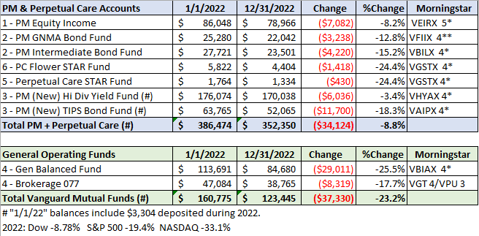
Annual Meeting 2023 (20230301).docx
Page 1 of 2

Superintendent’s Report:

Carol reported things have been slow. Dumpster will be turned on after wreath collection on the 15th.

The Grounds Report:

Drainage is good. Kurt’s costs have increased, and he is charging $500 for Saturday & Sunday. His business is still not moving forward.

There is a big maple by B section that may need to be looked at.

Mark asked the Town to make a salt run, but they said they could not since it would set a bad precedent. Gary may need to meet with the Town Supervisor to discuss the cemetery with him.

Sunshine Committee: Cards were sent to Gary and Linda. Carol got a card for her hip replacement.

Old Business: None

Nominating:

Gary read the list of directors whose terms are ending, Carol Feasel, Margaret Hayes, Scott Nevol, Gary Stockmaster,
1– Open Position.
The new officer nominations are President: - George Zornow, 1st Vice - Sue Comstock, 2nd Vice – John Hatch.
Superintendent - Carol Feasel, Secretary - Linda Stockmaster and Treasurer - Gary Stockmaster

Note: The board still has two openings. We should look for 1 or 2 possible new candidates for director positions. Website: Gary stated that the website continues to be used and was able to sell a grave over the phone.
Database: The database continues to be updated.
Open Forum: No visitors attended.

Margaret made a motion to adjourn the annual meeting with a second by Jim and all approved.

Next Annual Meeting – Wednesday, March 6th, 2024 (subject to change)

Directors and Officers Present:
Ray and Carol Feasel, Gary and Linda Stockmaster, Mark Feasel, Margaret Hayes, George Zornow,
Scott Nevol, Jim Comstock, Melanie Rajaphoumy and Sandra Ann Wilson.

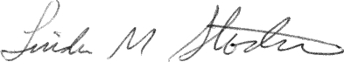
Secretary

Annual Meeting 2023 (202303196).docx Page 2 of 2

