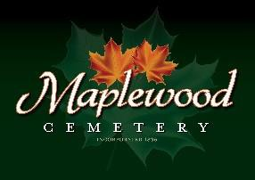

Maplewood Cemetery Association
24 Flinton Run
Churchville, NY 14428
Maplewood Cemetery Association

Quarterly Board Report
December 18, 2022
This is the December 2022 (Q4) Quarterly Board Report in place of a physical meeting.

Treasurer’s Business Report: Gary’s Business Report 4th Quarter 2022. Lower sales volume for all income items and negative investment fund returns across the board. Cremations outpaced full interments.
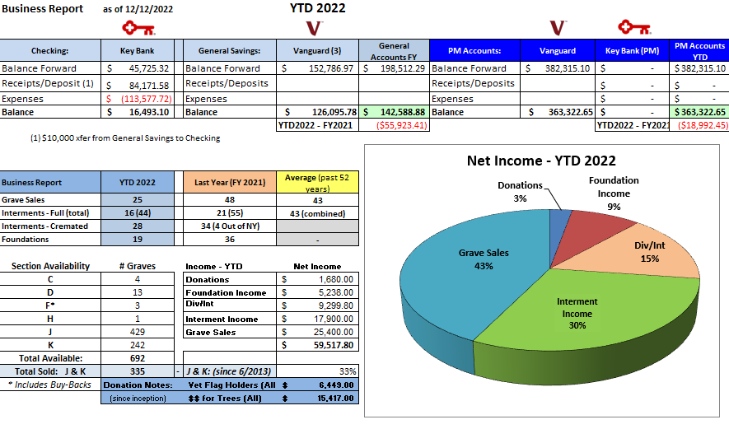

Finance Report: George reported we had a negative return, but it was not as bad compared to the S & P 500.

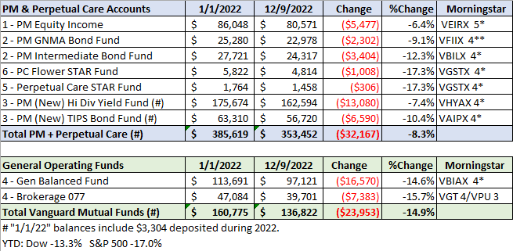

The 2023 Annual meeting, reviewing FY 2022, and the 1st Quarter 2023 board meeting will be held March 1st, 2023, 7 – 9 PM @ Henrietta Town Hall.
Reminders and any schedule changes will be sent out as usual.

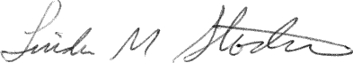
________________________________
Secretary

