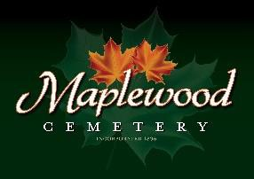

Maplewood Cemetery Association
24 Flinton Run
Churchville, NY 14428
Maplewood Cemetery Association

Quarterly Board Meeting
September 7, 2022
Vice President George Zornow brought the Directors Quarterly meeting to order.

Gary introduces Melanie Rajaphoumy as new board candidate. Board voted to approve her nomination.

Secretary’s Report: Linda read the minutes of the 2nd Quarterly report. A motion to approve was made by John, seconded by Hank and approved.

Treasurer’s Business Report: Gary’s Business Report 3rd Quarter 2022. A motion to accept was made by Mark seconded by Carol and approved.
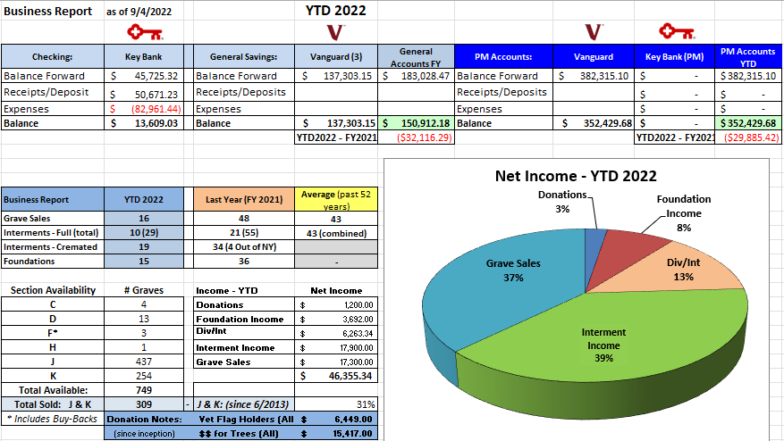

Finance Report: George reported we had a negative return, but it was not as bad compared to the S & P 500.

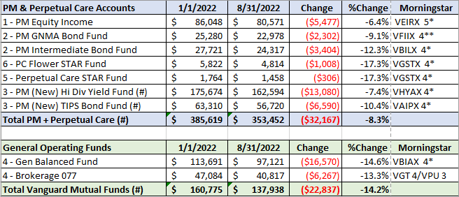

Sunshine Committee: Larry Rath has passed. Carol sent a card to his family. A donation of $100 was made to the Chili American Legion Post in memory of Larry Rath.

Superintendent’s Report: Looks great now that we had some rain.

Grounds Report: Had cracks sealed. 8 yds of topsoil were used and 4 more were purchased. A new gas can was purchased. The flagpole pulley was damaged, and the flag is gone. Scott will talk to the Legion Post and Jim will see about equipment that can reach to top to replace the rope and pulley.

Website: Website remains fully operational and heavily used. Last year over 341,900 hits were registered.

Database: Database is also fully operational and new backup procedures are in place.

Old Business:
- GVCS prices increased, and Shafer’s price increased.
- New Cemetery Rates were approved by NYS and went into effect July 1, 2022.
- Rustin paving completed the topcoat at entrance #2.
- Vet Flag Holders – 100 new flag holders were purchased, and a generous donation covered the expense.
- The new garden maintenance contract with Cardinal Landscaping is in effect and their work is looking good.
- The foundation repairs in Section A were sent to GVCS (Kurt) for pricing. Some of the repairs were approved.
- Nothing has been done to replace the old green signs.

New Business:
- MWC By-Laws review. John recommends a committee of himself, Gary, Scott, George and Melanie work on the By-Laws and present their findings at the annual meeting. Margaret should also be invited. Gary agreed to host at his house and will setup to review meetings.
- Some discussion was had about the salary we currently pay employees.
- Scott has agreed to work with Carol to learn what she does as superintendent.

The meeting was adjourned with a motion from by Jim and seconded by Sandra.

Next Meeting – The last Quarterly meeting of 2022, is scheduled for Wednesday November 2nd. This Meeting will be a business and financial report only and emailed to the board.

The 2023 Annual meeting and 1st Quarter board meeting will be held March 1st, 2023 @ Henrietta Town Hall.
Reminders and any schedule changes will be sent out as usual.

Directors and Officers Present: Ray and Carol Feasel, Gary and Linda Stockmaster, John Hatch, Mark Feasel, George Zornow, Scott Nevol, Hank Wallace, Sandra Wilson and Jim and Sue Comstock.
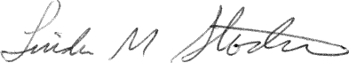
We welcome new board member Melanie Rajaphoumy!
________________________________
Secretary

