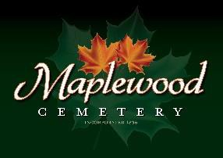

Maplewood Cemetery Association
24 Flinton Run
Churchville, NY 14428
Maplewood Cemetery Association

Quarterly Board Meeting
June 1, 2022
President Margaret Hayes brought the Directors Quarterly meeting to order.

Secretary’s Report: Linda read the minutes of the 1st Quarterly report. A motion to approve was made by George, seconded by John and approved.

Treasurer’s Business Report: Gary’s Business Report – 2nd Quarter 2022. A motion to accept was made by Mark seconded by Sue and approved.
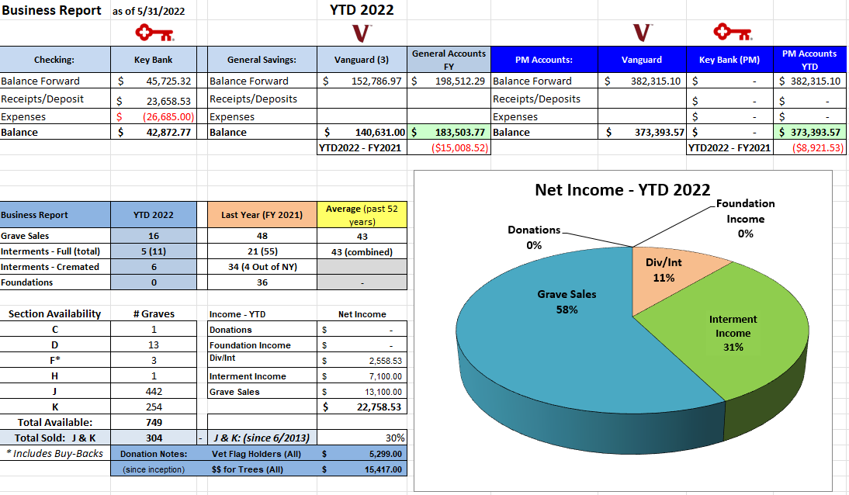

Finance Report: George reported we had a negative return but it was not as bad compared to the S & P 500.

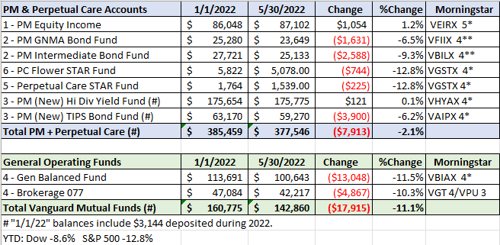

Sunshine Committee: Phyllis fell, and Carol will send her a card. Larry Rath is not doing well and will send a card to him.

Superintendent’s Report: Mark wanted to thank the Legion for putting out all the Flags. He had received several compliments. Margaret will pass this along. If a VET Flag and holder is put out, please let Gary or Linda know since they are tracked in the database. The Tractor has helped grave toppings.

Grounds Report:
Purchased 8 yds if topsoil to top graves. Karen Langenhofer puts out flowers on several graves and the ones in section D were mowed over. Gary has spoken to Chris Schafer. Improvements will occur next week to Middle Road.
Website: Website is fully operational and heavily used.

Database: Database is also fully operational and new backup procedures are in place.

Old Business:
- Nothing has been done to replace the old green signs.
- Gary has changed our gardening maintenance Spring Cleanup scope with Chris Shafer
- New contract with Cardinal Landscaping for shed berm, memorial garden, front garden, and East hill garden are active.
- Walkthrough was held on April 23rd. We need a report of the foundations that need repairs in the A & B sections that were found during the walkthrough. Gary will have Kurt take care of them.
- The Waste Management contract was reviewed and revised. Carol was able to get our bill lowered.
- Mark would like to revisit the pay we have for various positions like treasurer. Establish a transition plan.
- John recommends payment for the treasurer’s position.

New Business:
- GVCS price increases and Shafer price increased.
- Cemetery Rates were reviewed. Last grave price increase was January 2012. We have reviewed our rates for competitiveness, based on 2021 data. Rate increases were discussed and a motion by Gary, seconded by George and were approved. They will go into effect July 1st, if approved by NYS. The proposed price list is attached.
- Rustin paving estimates were reviewed. Gary proposed the $8,050 to topcoat entrance #2, seconded by Jim and approved.
- Vet Flag Holders – need to purchase additional holders. Only 9 holders remain, and Gary proposed to order another 100, seconded by John and approved.
- Mark advised that gas mowers may be banned in 2027 and should considered buying one to replace the Scag in the next few years.

The meeting was adjourned with a motion from by Carol and seconded by Jim.

Next Meeting – The next Quarterly meeting of 2022, is scheduled for Wednesday September 7th @ 7 PM. Meeting reminders will be sent out as usual.

Directors and Officers Present Carol Feasel, Gary and Linda Stockmaster, John Hatch, Mark Feasel, Margaret Hayes, George Zornow, Scott Nevol, and Jim and Sue Comstock.
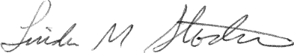
________________________________
Secretary

