

Maplewood Cemetery Association
24 Flinton Run
Churchville, NY 14428
Maplewood Cemetery Association

Quarterly Board Meeting
March 2, 2022
President Mark Feasel brought the Directors Quarterly meeting to order.

Secretary’s Report: Linda read the minutes of the December 2021 Quarterly report. A motion to approve was made by Ray, seconded by George, and approved.

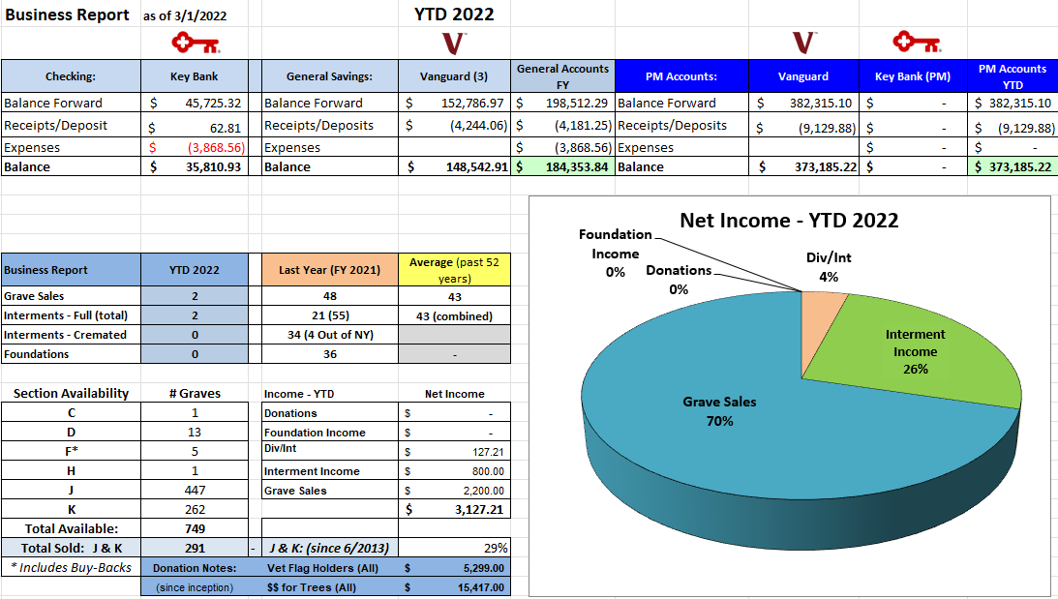
Treasurer’s Business Report: Gary’s Business Report – 1st Quarter 2022. A motion to accept was made by John seconded by Scott and approved.

Finance Report: George reported we had a negative return.
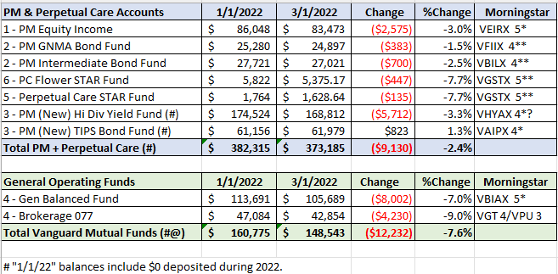

Sunshine Committee: Nothing to report.

Superintendent’s Report: We had a lot of snow, and it was hard to find grave markings.

Grounds Report:
- John Deere Tractor: $24,257.55
- Mason Trenching Co.: Sections J&K drainage project: $12,500
- Cardinal Lawn & Landscape: Shrub trimming, Lawn soil repair: $5,410.00
- Ruston Paving Co.: Road repair, shed ramp paving and dumpster pad extension: $16,417.00
- TruGreen delivered 2 weed and feed treatments. Weeds remain under control.
- Road sealing should be planned.

Nominations:
- Gary Stockmaster, George Zornow, Hank Wallace, John Hatch, Ray Feasel were approved for another 3-year term as Board Directors.
- The following officers were approved for a 1-year term:
  - Margaret Hayes – President
  - George Zornow – 1st VP
  - Sue Comstock – 2nd VP
  - Carol Feasel – Superintendent
  - Linda Stockmaster – Secretary
  - Gary Stockmaster - Treasurer
Website: We have been recovering from a ransom attack. Steps have been made to secure the data in the future.

Database: Was recovered from our hosting site. No data was lost. Grave photos reside on our hosted site for now.

Old Business:
- Nothing has been done to replace the old green signs.

New Business:
- Chris Shafer – Gary recommended a change in our gardening maintenance. Spring Cleanup
- Includes: All ‘new’ trees with a mulch border. Remove leaves and debris, edge and mulch most gardens and tree beds in the spring. Price includes materials and labor. All work to be completed prior to Memorial Day.
- Setup new contract with Cardinal Landscaping for shed berm, memorial garden. front garden and East hill garden.
- Walkthrough is scheduled for April 23rd Saturday at 10am.
- Need to schedule Rustin paving to topcoat entrance #2. Gary will call for estimate.
- Mark would like to revisit the pay we have for various positions like treasurer. Establish a transition plan.
- John recommends payment for the treasurer’s position.
- Carol would like to review our rate for competitiveness.
- Gary will provide our current trash contract to Carol for review.

The meeting was adjourned with a motion from by John and seconded by Hank.

Next Meeting – The next meeting, 2nd Quarter meeting of 2022, is scheduled for Wednesday June 1st @ 7 PM.
Meeting reminders will be sent out as usual.

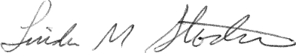
Directors and Officers Present Ray and Carol Feasel, Gary and Linda Stockmaster, John Hatch, Mark Feasel, Margaret Hayes, George Zornow, Scott Nevol, Hank Wallace and Sandra Ann Wilson.
Secretary

