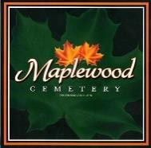
Maplewood Cemetery Association

150 Middle Road
Henrietta, NY 14467 125th Annual Meeting (Reviewing 2021)

Held on March 2, 2022, at Henrietta Town Hall

President Mark Feasel called the Annual Meeting to order.

Secretary Report: The minutes of the last annual meeting of March 2021 were read by Linda Stockmaster. Carol made a motion to approve the minutes, seconded by John and approved.

Treasurer Report: Gary provided a summary of the financial position in the Treasurer’s business report.

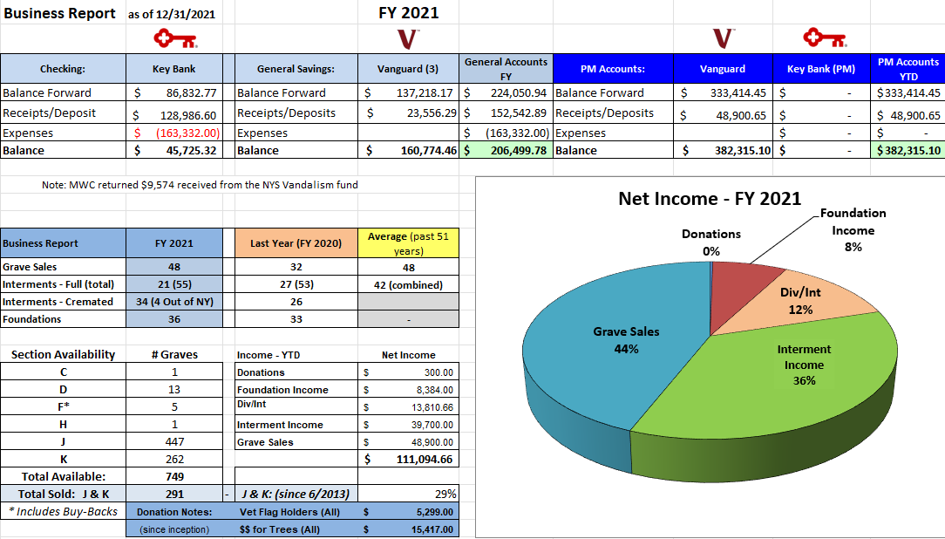

A motion was made by Ray and seconded by Scott to approve the treasurer’s FY2021 business report and it was approved.

Finances: George presented the FY 2021 finance report. Good investment into Vanguard with a 17.2% increase.
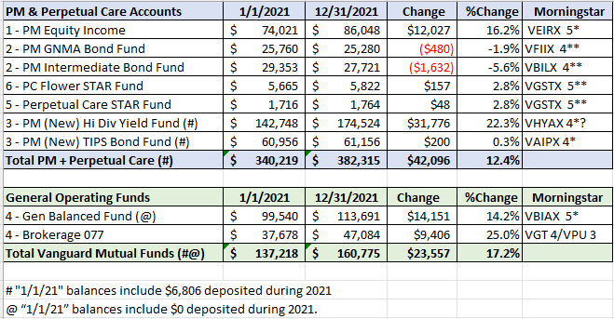
Page 1 of 2

Annual Meeting 2022 – final (20220303).docx

Superintendent’s Report:

Carol reported it has been slow lately. Things have been good.

The Grounds Report:

- The drainage in Section J & K are doing well.
- Plywood stand was improved.
- New barrier was installed for topsoil.
- New and expanded dumpster pad is working great.
- New Tractor helped push back snow to assist with plowing the driveways.
- The new tractor will be a great help in the spring for topping graves.
- Eagle Project to improve East hill garden looks good and is easier to maintain.
- Carol will start dumpster service March 15th and investigate competitive bids from other companies. Gary will send her our current payments for our service.

Sunshine Committee: Cards were sent to George who fractured his arm and Linda who broke her ankle. She also wished Ray well on his prostate cancer. He may start treatment soon.

Old Business: None

Nominating:

Gary read the list of directors whose terms are ending, George Zornow, Hank Wallace, John Hatch, Ray Feasel
2– Open Positions.
The new officer nominations are President: - Margaret Hayes, 1st Vice - George Zornow, 2nd Vice – Sue Comstock
Superintendent - Carol Feasel, Secretary - Linda Stockmaster and Treasurer - Gary Stockmaster

Note: The board still has two openings. We should look for 1 or 2 possible new candidates for director positions. Website: Gary stated that the website continues to be used and was able to sell a grave over the phone.
Database: The database continues to be updated.
Open Forum: No visitors attended.

Carol made a motion to adjourn the annual meeting with a second by Scott and all approved.

Next Annual Meeting – Thursday, March 2nd, 2023 (subject to change)

Directors and Officers Present:
Ray and Carol Feasel, Gary and Linda Stockmaster, John Hatch, Mark Feasel, Margaret Hayes, George Zornow, Scott Nevol Hank Wallace and Sandra Ann Wilson.
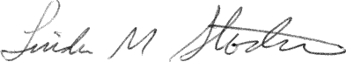
Secretary

Annual Meeting 2022 – final (20220303).docx Page 2 of 2

