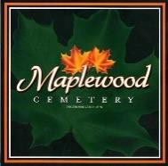
Maplewood Cemetery Association

150 Middle Road
Henrietta, NY 14467

General Format Annual Meeting

President: Call the Meeting to order.

Secretary Report: Read minutes of the last annual meeting.
Need a motion to approve the minutes and approved.

Treasurer Report: Provide a summary of the financial position in the Treasurer’s business report.
Need a motion to approve the minutes and approved.

Finance Report: Information only no motion needed.

Superintendent’s Report:

The Grounds Report:

Sunshine Committee:

Old Business:

Nominating: (1st Qtr. Meeting only: Read nominations)

Website:
Database:
Open Forum:
Next Annual Meeting:

