Maplewood Cemetery Association
244 Edgemoor Road
Rochester, NY 14618
Maplewood Cemetery Association Quarterly Board REPORT December 3, 2021


This is a YTD/Quarterly business & financial report instead of a physical meeting

Treasurer’s Business Report: Gary: Business Report – YTD 2021. The full 4th quarter and annual reports will be available at the 2022 annual meeting.

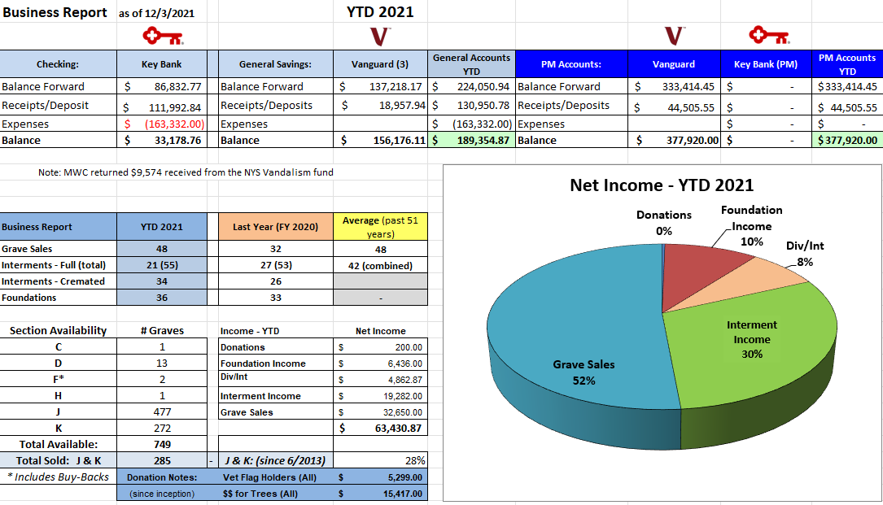
Finance Report: George Zornow
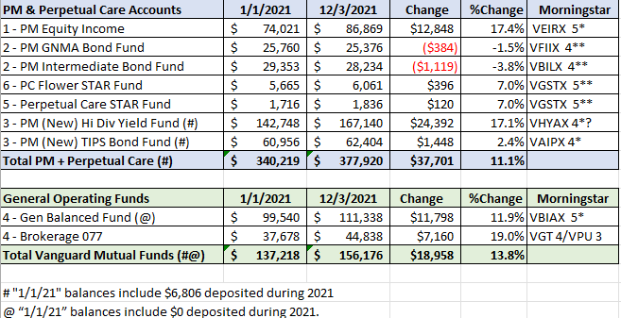

Business Report: Details

Maplewood Cemetery had a few large expenses the last half of 2021.
- John Deere Tractor: $24,257.55
- Mason Trenching Co.: Sections J&K drainage project: $12,500
- Cardinal Lawn & Landscape: Shrub trimming, Lawn soil repair: $5,410.00
- Ruston Paving Co.: Road repair, shed ramp paving and dumpster pad extension: $16,417.00
- NYS Division of Cemeteries: Return of vandalism funds: $9,574.00
  - Total of these projects: $68,158.55

Ransomware Attack:
- The data storage server used for MWC at my home was hacked. This hack locked virtually all the data files, literature-form files, financial reports, map files, website files and the MWC database. This attack was also sophisticated enough to lock the back-up files on an external device. The QuickBooks accounting files were not impacted.
- The ransom was NOT paid since there reportedly is a low probability of ever getting the files unlocked.
- Many of the source files and the MWC database were rebuilt using the MaplewoodCemetery.org files and the backup files stored on the webserver. This all took several days for Linda and me to rebuild.
- The good news is that MWC business continued without a noticeable interruption.
- The data server and network technology has been enhanced to hopefully avoid any future attacks. The backup strategy of using the MaplewoodCemetery.org website for critical file retention has been enhanced. We will continue to make the system safer. We certainly do not want to go through anything like this again!

Federal Tax Payment Changes:
- MWC has been notified of 2 IRS required changes:
  - Federal tax withholding now must be paid electronically (EFTPS) within 15 days after the monthly payroll withholding, instead of quarterly. The reporting form is still only required quarterly.
  - The annual IRS 990 filing to maintain our ‘not-for-profit’ status now must be electronically submitted via E-File, not a paper form submission. The E-Filing is only available through a limited number of IRS approved sites, for a price. We were required to resubmit the 2020 IRS 990 form electronically via E-File.

New Business Office Address!
- Linda and I will be moving in the next few weeks to Chili (Churchville zip code) and have started the process of preparing our forms, checks, and contact information for the new address.



Next Meeting – The next scheduled meeting, will be the annual meeting of 2022, scheduling is subject to any pandemic restrictions in the March timeframe.


Secretary

