Maplewood Cemetery Association
244 Edgemoor Road
Rochester, NY 14618
Maplewood Cemetery Association Quarterly Board Meeting September 1, 2021


Mark Feasel called the Directors Quarterly meeting to order.

Presentation: Introduce Sarah Ellis for her BSA Eagle Scout Project proposal to expand the East hill garden to honor our veterans. A motion was made by Mark to donate up to $750, seconded by Hank and approved. Scott donated $200 to the project. There was a discussion about listing all the wars we have veterans for on a stone.

Secretary’s Report: Linda read the minutes of the June 2021 Quarterly meeting. A motion to approve was made by Scott seconded by George and approved.
Treasurer’s Business Report: Gary: Business Report – 3rd Quarter 2021. A motion to accept was made by Carol seconded by Hank and approved.
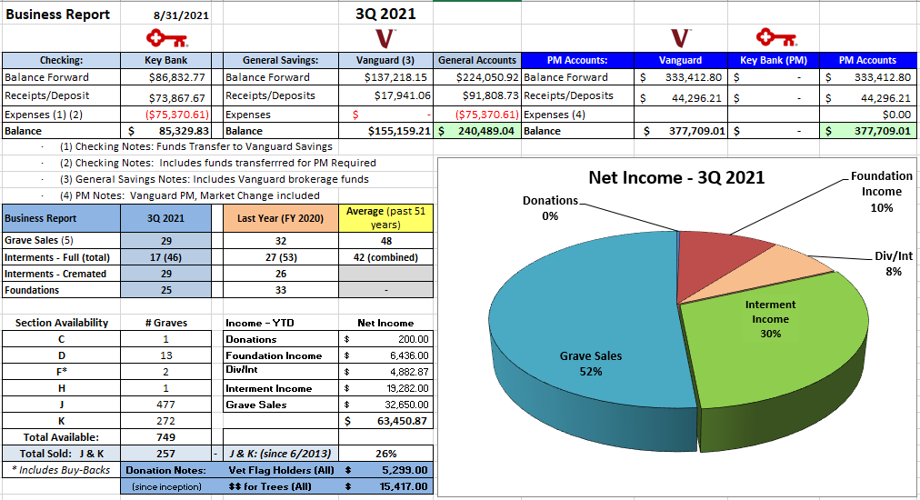

NOTE: MWC returned the $9,574 received from the NYS Division of Cemeteries for the Section C damage. Financial Report:
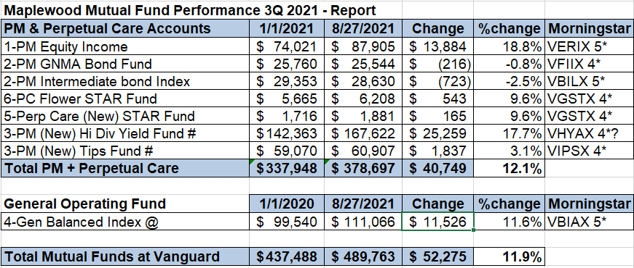

Sunshine Committee: Carol had nothing to report.

Superintendent’s Report: Carol said grass is looking great. Steady burials about 2 to 3 a week.

Grounds Report: Ruston Paving jobs complete. Cracks were sealed and dumpster pad poured. J&K Drainage project in progress by Mason Trenching continues.
Cardinal Landscaping completed the shrub trimming, garden maintenance and new paving backfill and seeding. TruGreen has applied the August treatment.

Website: Cozi is working well. It is being used for interment scheduling, foundation staking, and payroll reporting. The internal and customer websites are up to date.

Database: Frequently updated and is the data source for the MWC websites.

Old Business:
- Status: John Deere 2025R Compact Utility Tractor with 120R loader: $18,056 (with HGAC contract pricing)
- Succession planning: Jim suggested we look at this as a business if in the future we need to pay people to do our jobs. It was suggested we put together job descriptions and look at our long-term plan.

New Business:
  - New BSA Eagle Scout project proposal from Sarah Ellis RE: Veteran Garden addition to the East Hill Garden area. Approved Mark made the motion, and it was 2nd Hank.
  - Large limb in section B tree needs taken down.
  - Legion Post: Requesting 13 flag holders for their front flag memorial area. Earl Morris 570.560.1516
    - Prefer they be returned at some point.
  - Grave topping, how should that be managed? Waiting for Tractor in October.
  - Dumpster pad, divider(s) to separate dumpster from topsoil. Ray will check Lakeland for stand-alone barriers.
  - Seasonal landscape maintenance:
    - Chris Shafer provides a spring garden cleanup with edging and much. ~$1,500 (May)
      - Propose changing to eliminate shed berm garden and Middle Road gardens. Est ~$1,200.
    - Propose: Cardinal Landscape: 2/year (June, August) shrub pruning, edging, mulching with weed pre- emergent and monthly (April – Oct) garden weeding for shed berm garden and Middle Road gardens.
~$1,560 Motion to approve by Gary seconded by Linda and approved.
  - Gary Proposed cancelling the November 3rd Quarterly board meeting due to resurgence of COVID-19. George and Gary will prepare and distribute the Q4 business and financial report in place of the meeting. Carol agreed by seconded by Ray.

The meeting was adjourned with a motion from by Hank and seconded by Gary.

Next Meeting – The next Annual and 1st Quarterly Board Meeting: Wednesday March 2nd, 2022 (7 PM – 9 PM). Meeting updates and reminders will be sent out as usual.

Directors and Officers Present: Ray and Carol Feasel, Gary and Linda Stockmaster, John Hatch, Mark Feasel, Margaret Hayes, Scott Nevol, George Zornow, Sandra Ann Wilson and Sebold Torno.

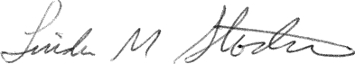
Secretary

