Maplewood Cemetery Association
244 Edgemoor Road
Rochester, NY 14618
Maplewood Cemetery Association
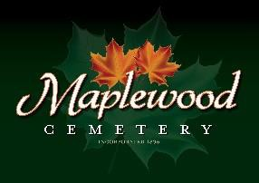
FY 2019 Report
January 18, 2020

Treasurer’s Business Report: Gary - This is the FY 2019 Business report which replaces the Q4 Report and extends the timeframe to all of FY 2019. The November 2019 meeting was cancelled.

Finance Report: George Zornow – This is the FY 2019 Finance report

Secretary Update: Linda – Next meeting will be the Annual and 1Q2020 Meeting on THURSDAY March 5, 2020 @ 7PM at the Henrietta Town Hall.

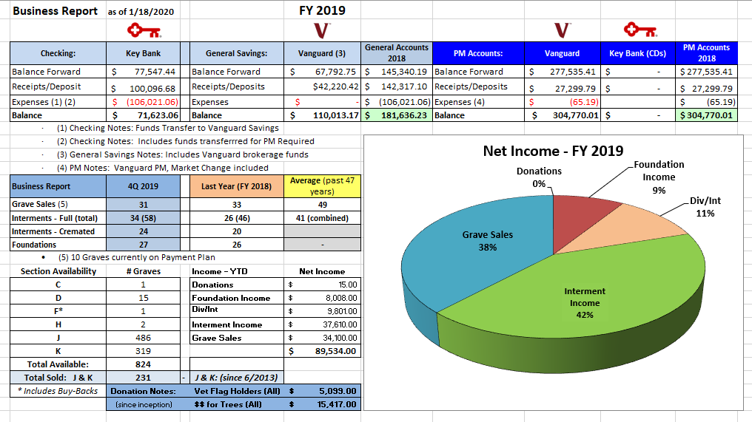
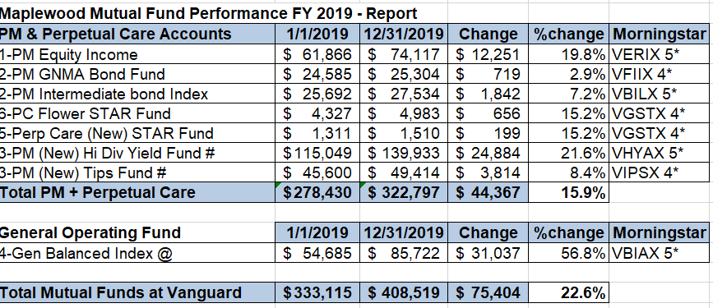

FY2019 Report (20200118) - final.docx Page 1 of 1

