Maplewood Cemetery Association
244 Edgemoor Road
Rochester, NY 14618
Maplewood Cemetery Association Quarterly Board REPORT December 21, 2020

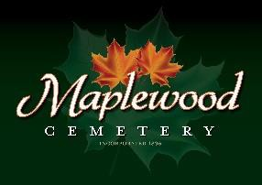
This is a quarterly report instead of a physical meeting

Secretary’s Report: Attached is the 3Q meeting minutes. Treasurer’s Business Report: Gary: Business Report – 4th Quarter 2020. The full 4th quarter and annual reports will be available at the 2021 annual meeting.

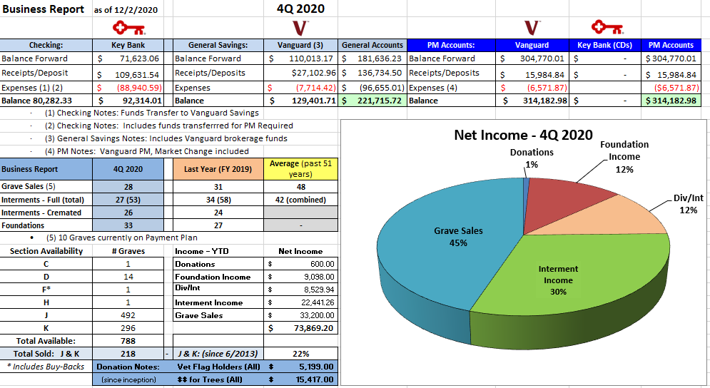
Finance Report: George Zornow
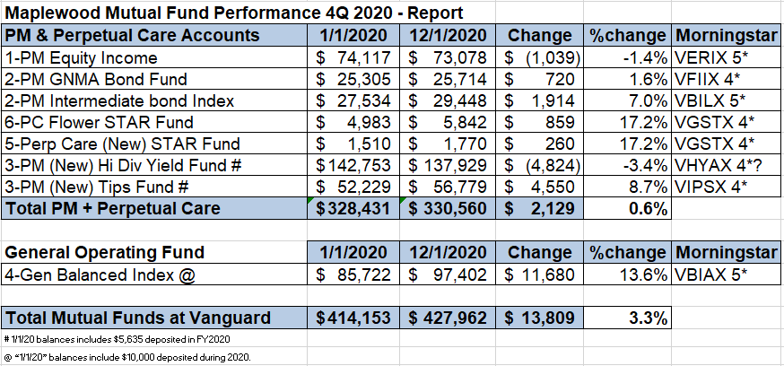

Directors 4Q Report (202001221) - final .docx Page 1 of 1

