Maplewood Cemetery Association
244 Edgemoor Road
Rochester, NY 14618
Maplewood Cemetery Association Quarterly Board Meeting September 2, 2020


President Hank Wallace called the Directors Quarterly meeting to order.

Secretary’s Report: Linda read the minutes of the June 2020 Quarterly meeting. A motion to approve was made by George, seconded by Carol and approved.
Treasurer’s Business Report: Gary: Business Report – 3rd Quarter 2020. A motion to accept was made by Mark, seconded by George and approved.

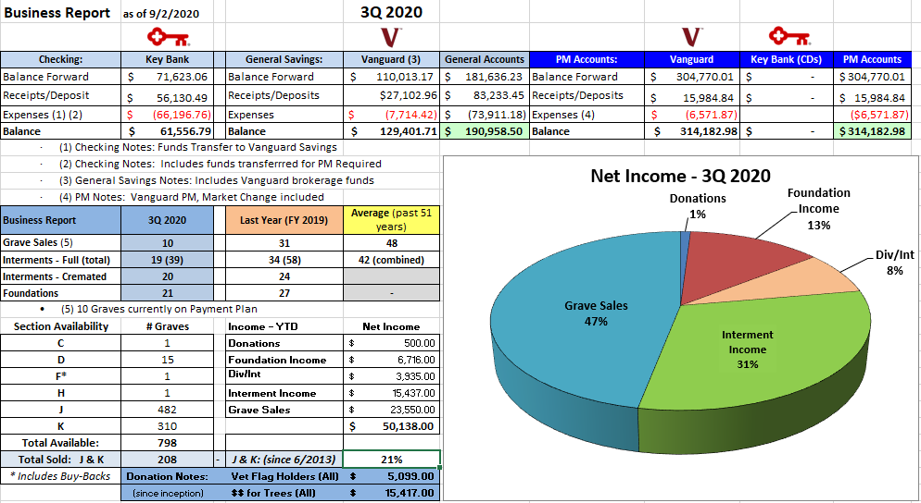

Finance Report:
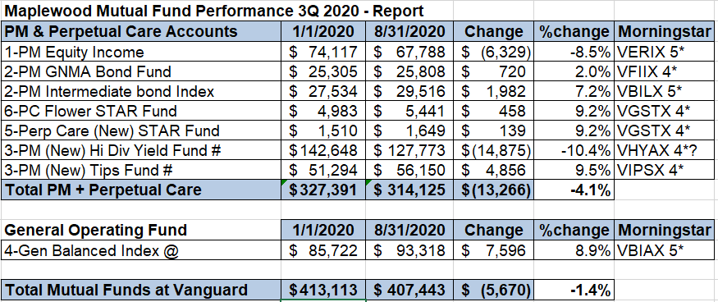

Sunshine Committee: Card sent to Gary in July.

Superintendent’s Report: Cemetery continues to look great! Large US flag replaced by Legion Post.

Grounds Report: A tree in the B section was removed and a large branch near K section was also removed by Quality Tree. Bug Man was called for a large paper wasp nest in a maple tree. Ground hog issue in A section.

Website: Continues to be heavily used and frequently updated.
Database: Updated frequently and feeds the website.

Old Business:
- Sec. J-K drainage no update
- BSA Troops 167 and 2019 completed several service projects, totaling more than 40 hours.
- No action taken on road 2 repair
- No action on road sealing

New Business:
- Replace signs, big green signs on roads 2 and 4. Wait until spring.
- Recommend having Ruston Paving quote shed ramps and possibly entrance 2 repairs in the spring.
- Need to have a ‘board’ walk-through in the spring to identify and fix bumped monuments and make a list of any foundations that need repair.
- Contact TruGreen in the spring to review the J Section.

Proposal: no physical Q4 meeting. Gary and George will prepare the Q4 report and email it in December. Any additional content can be emailed to Gary for inclusion in the report. Approved

The meeting was adjourned with a motion by Carol and seconded by George.
Note: This meeting was held at the cemetery to allow for physical distancing during the Covid-19 pandemic.

Next Meeting – The next scheduled meeting, will be the annual meeting of 2021, scheduling is subject to any pandemic restrictions in the March timeframe.
Directors and Officers Present: Hank Wallace, George Zornow, Ray and Carol Feasel, Gary Stockmaster, John Hatch, Mark Feasel, Margaret Hayes, Jim and Susan Comstock, Scott Nevol and Sandra Wilson.

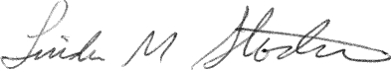
Secretary

