Maplewood Cemetery Association
244 Edgemoor Road
Rochester, NY 14618
Maplewood Cemetery Association


Quarterly Board Meeting
March 5, 2020

President John Hatch called the Directors Quarterly meeting to order.

Secretary’s Report: Linda read the minutes of the September 2019 Quarterly meeting. A motion to approve was made by Scott, seconded by Ray and approved.
Treasurer’s Business Report: Gary: Business Report – 1st Quarter 2020. A motion to accept was made by Jim seconded by Scott and approved.

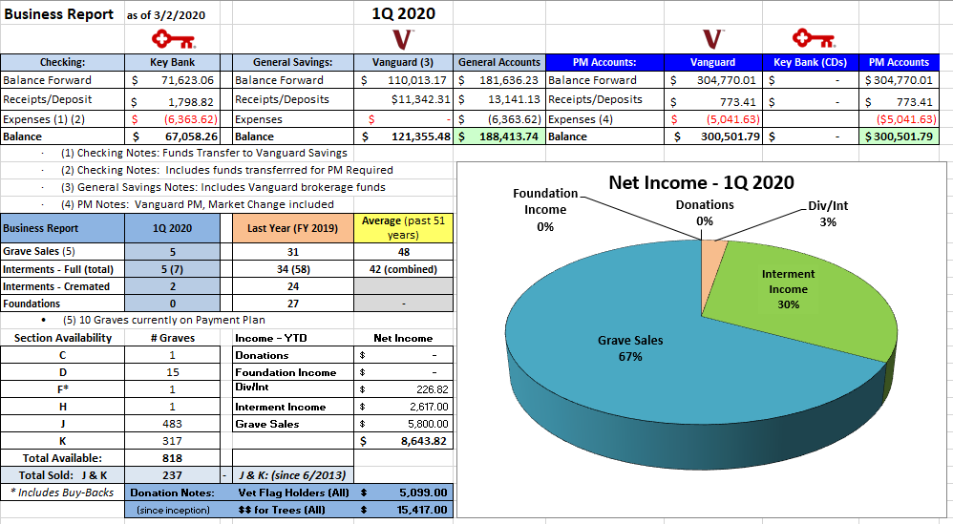

Finance Report:

PM & Perpetual Care Accounts | 1/1/2020 | 2/29/2020 | Change | %change | Morningstar
1-PM Equity Income | $ 74,117 | $ 65,950 | $ (8,167) | -11.0% | VERIX 5*
2-PM GNMA Bond Fund | $ 25,305 | $ 25,568 | $ 263 | 1.0% | VFIIX 4*
2-PM Intermediate bond Index | $ 27,534 | $ 28,677 | $ 1,143 | 4.2% | VBILX 5*
6-PC Flower STAR Fund | $ 4,983 | $ 4,803 | $ (180) | -3.6% | VGSTX 4*
5-Perp Care (New) STAR Fund | $ 1,510 | $ 1,455 | $ (55) | -3.6% | VGSTX 4*
3-PM (New) Hi Div Yield Fund # | $ 139,933 | $ 123,098 | $ (16,835) | -12.0% | VHDYX 4*
3-PM (New) Tips Fund | $ 49,414 | $ 50,951 | $ 1,537 | 3.1% | VIPSX 4*
Total PM + Perpetual Care | $ 322,796 | $ 300,502 | $ (22,294) | -6.9%
General Operating Fund | 1/1/2020 | 2/29/2020 | Change | %change
2-Gen Balanced Index | $ 85,722 | $ 82,596 | $ (3,126) | -3.6% | VBIAX 5*
Total Mutual Funds at Vanguard | $ 408,518 | $ 383,098 | $ (25,420) | -6.2%
PM 1/1/20 includes $0 deposits.
Gen Bal Fund includes $10,00 deposits.

Sunshine Committee: No report

Superintendent’s Report: No Report

Grounds Report: Road sealing should be planned.

Nominations:
- Gary Stockmaster, Margaret Hayes, Scott Nevol, Sebold Torno were approved for another 3-year term as Board Directors.
- The following officers were approved for a 1-year term:
  - John Hatch – President
  - Hank Wallace – 1st VP
  - Mark Feasel – 2nd VP
  - Carol Feasel – Superintendent
  - Linda Stockmaster – Secretary
  - Gary Stockmaster - Treasurer
Website: No Report

Database: No Report

Old Business:
- The Spectrum Wi-Fi, security cameras, bug zapper and LED lights was installed. New lock box was added. New steel door was installed and painted. All equipment stolen was replaced.

New Business:
- Chris Shafer – Spring garden clean up proposal approved, $1,300
- Stihl Power broom attachment motion by Gary, 2nd by George, and was approved (~$300).
- New mower from C&B was discussed. Gary will apply for HGAC membership to get a 15% discount. Jim mad a motion to purchase the mower and it was seconded by Susan and approved. The John Deer tracker will be sold.
- New openers for the big door and Gator door and an upgrade for the old shed door were proposed. Gary will contact Felluca and make the new openers internet accessible. Motion was made to purchase up to $750 by Mark, seconded by Scott and approved.

The meeting was adjourned with a motion from by George and seconded by Linda.

Next Meeting – The next meeting, 2nd Quarter meeting of 2020, is scheduled for June 3rd @ 7 PM. Meeting reminders will be sent out as usual.

Directors and Officers Present George Zornow, Ray Feasel, Gary and Linda Stockmaster, John Hatch, Mark Feasel, Margaret Hayes, Jim and Susan Comstock, Scott Nevol and Sebold Torno.


Secretary

