Maplewood Cemetery Association
(585) 672-1020
Business Office:
(585) 473-2609

info@MaplewoodCemetery.org



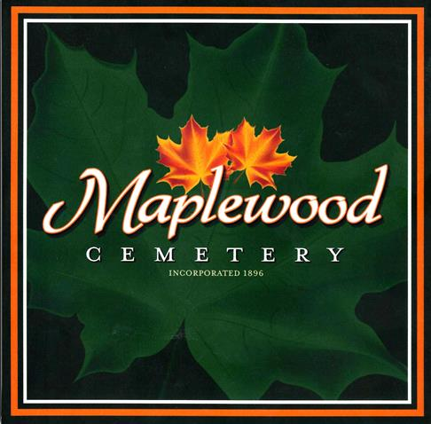

150 Middle Road
Henrietta, NY 14467

