Welcome,

Enclosed is the deed to your recently purchased lot in Maplewood Cemetery located in Henrietta, New York. This purchase made you a member of the Maplewood Cemetery Association. Please read the accompanying information we have provided with your deed to help answer questions about the cemetery and the rules & regulations.

The Maplewood Cemetery Association has the responsibility of operating and maintaining the premises. Officers and directors are nominated from the association membership.

As a member of the association, you may be called upon to serve on the board of directors. Please be willing to honor this privilege and responsibility by volunteering or if requested to serve. The active participation of all members is both desirable and necessary.
-------

The annual meeting of directors and the election of officers is usually held the first Wednesday of March, at 7 PM. at the Henrietta Town Hall on Calkins Road.

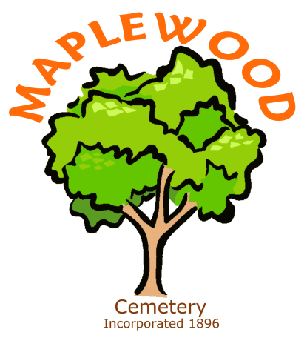

Maplewood Cemetery Association
585-672-1020
info@MaplewoodCemetery.org


The Maplewood Cemetery web-site includes maps, listings, photos, history, rules & regulations, pricing, donation programs, and frequently asked questions that may provide more information about the cemetery.

