Maplewood Cemetery
Rates & Charges

2026
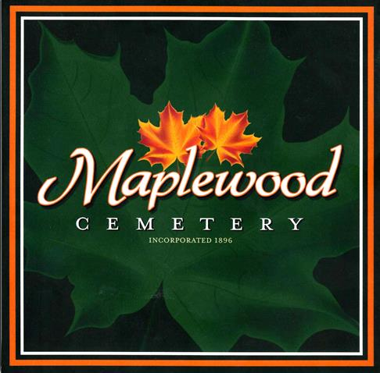

150 Middle Road
Henrietta, NY 14467

Maplewood Cemetery Association
Rates and Charges
2026
Lot Sales:
Full size (per grave) | $1,200
Cremation-only (Section J) | $600
Interments: (1)
Adult and Child full/vault | $1,000
Adult oversized full/vault | $1,200
Infants (up to 4 ft.) | $600
Cremated Remains -  Human (urn) | $800
Cremated Remains –  Pet (urn) (2) | $800
Additional Fees:
Special Grave  Maintenance fee (3) | $200
Weekend & Holiday | $600
After 3 PM, any day | $500
Disinterment Fee cremains | $1,500
Disinterment Fee full/vault | $3,000
Monument Foundations:
Per square inch | $1.80
Minimum Charge | $519
Duplicate Deed: | $10


For Burial and Cemetery information:

Maplewood Cemetery Voicemail 585-672-1020

Visit us at:
www.MaplewoodCemetery.org

Email us at:
info@MaplewoodCemetery..org

Notes:
- (1) The Rates and Charges include the 2001 NY State mandatory charge of $35.00 to our Permanent Maintenance account for interments and a $5 vandalism fee.
- (2) Cremated pets that require a separate grave opening.
- (3) The Special Grave Maintenance Fee will be charged for exceptions to the concrete vault or concrete liner requirements.

Please make checks out to:
Maplewood Cemetery Association

The Maplewood Cemetery Association is a not-for-profit, charitable, volunteer-run community cemetery



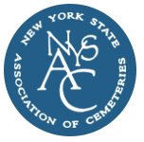

MWC Rates & Charges (20250401)

