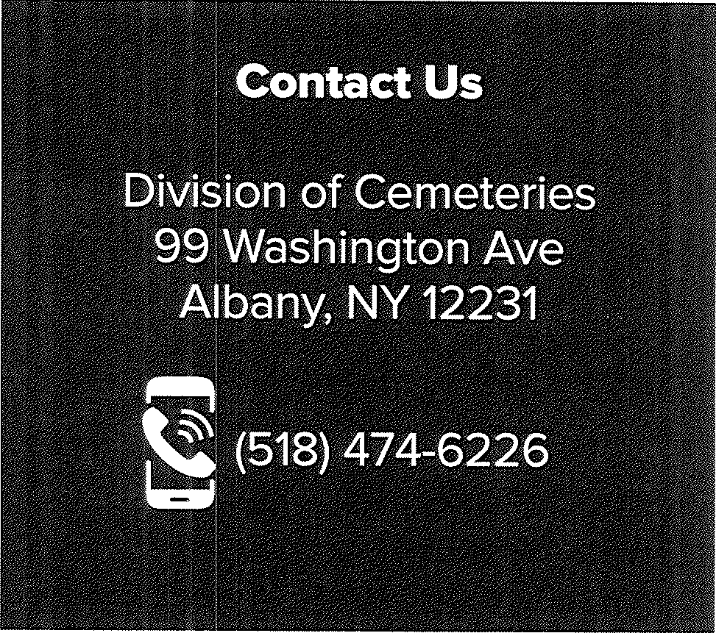
:!:: l!)
IL
u l!)
§;
5fK I
Department of State

:z< :::r ( J
ATE
Cemeteries

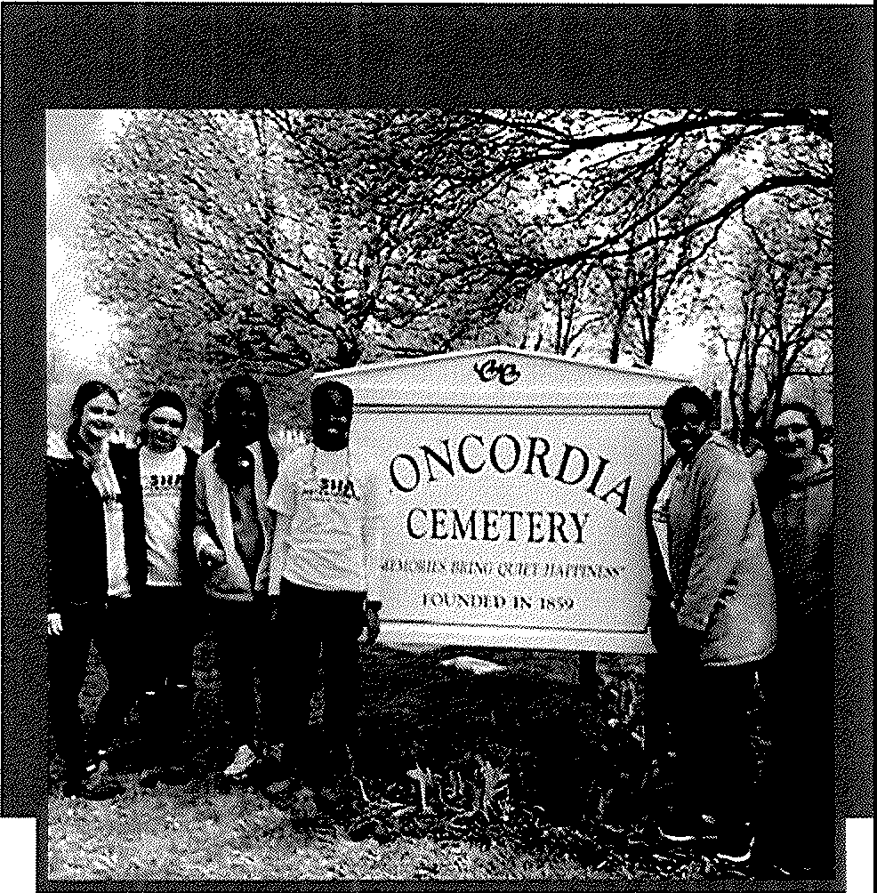
r::\ - r.:,
-< 5·
. (!J
N ,....
w^{NO} ::J
. )>
<
<D

-4::tl
l'l"I;:::

nc
(I) CD
3 "C
!!a. 1).)
(I) ..,
m· 3
""'I,....

VI CD
a

a


C
lu
r
Honor the past, shape the future, contribute to your community.

\+:.:I-;-!::•;ii:iI: - L.•,!.,
r
. ..1 ".-
: :..:.•. :.. . ;:
1,0c5fK 1 Department of State
19 ;!_ATE Cemeteries
0
:

(!J=:.::-r·= .. -t..::.
DOS.NY.GOV/CEMETERIES

"Volunteers do not necessarily have the time; they have the heart."
- Elizabeth Andrew

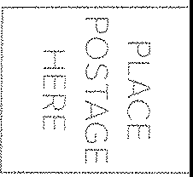
Kathy Hochul Governor

Robert J. Rodriguez Secretary of State

Bl'Jll"lafi'liiK& l!B:Illai._.11\lllB?l l?iiH ■l'•itfiif!llfill iiiliilfll1111111-9:i11fli!

.Jl rK I
ATE
Department of State


Cemeteries

The Division of Cemeteries proudly supports a rich history of cemeteries, regulating approximately 1,700 of
the state's 6,000 cemeteries. These cemeteries are all public not-for-profit corporations.
Most of our cemeteries are small and rely on the dedication of volunteer boards. Volunteers provide essential support and resources to ensure these
cherished spaces remain vibrant and well­ maintained, honoring the legacy of those who have come before us.
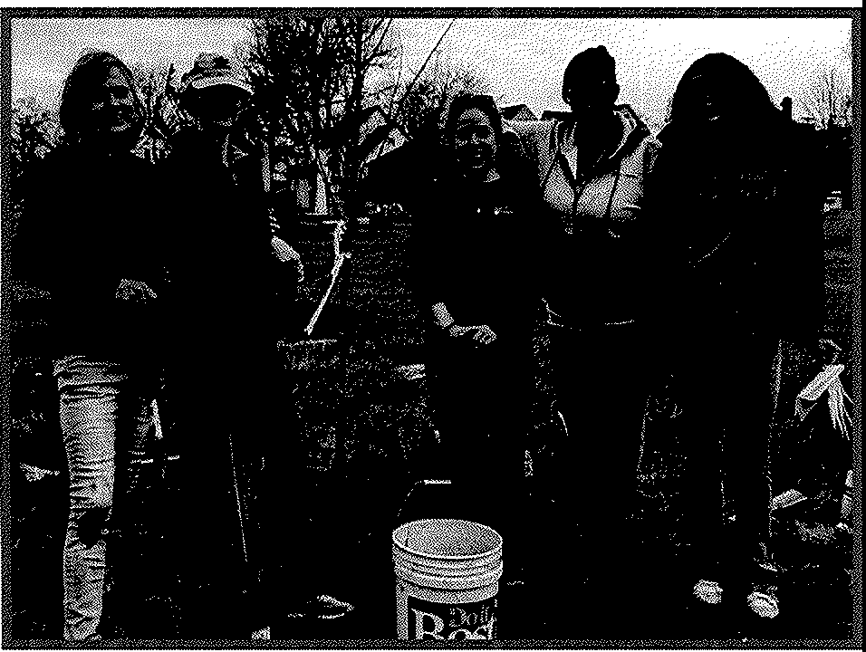
Volunteer and join us in our mission to keep New York's cemeteries thriving now and for future generations.
Many of our cemetery boards seek volunteers with various experience and skills. Also, if you are a retiree with a love for community service, we encourage you to consider volunteering your time, talent and expertise. Whether you're a seasoned expert or just starting out, we have a place for you.
Consider volunteering if you have experience in the following:
- Administration
- Bookkeeping or Filing
- Building and Repair Skills
- Customer Service
- Data Entry
- Grant Writing
- Finance
- Fundraising
- Landscaping or Lawn Maintenance
- Law
- Preservation of Records
- Sales
- Social Media or Marketing
- Surveying
If you are interested in volunteering or finding out more information, please contact your local cemetery or the New York Department of State Division of Cemeteries at (518) 474-6226.
The Division of Cemeteries also provides presentations and training about best practices to groups, classes, organizations, and stakeholders.
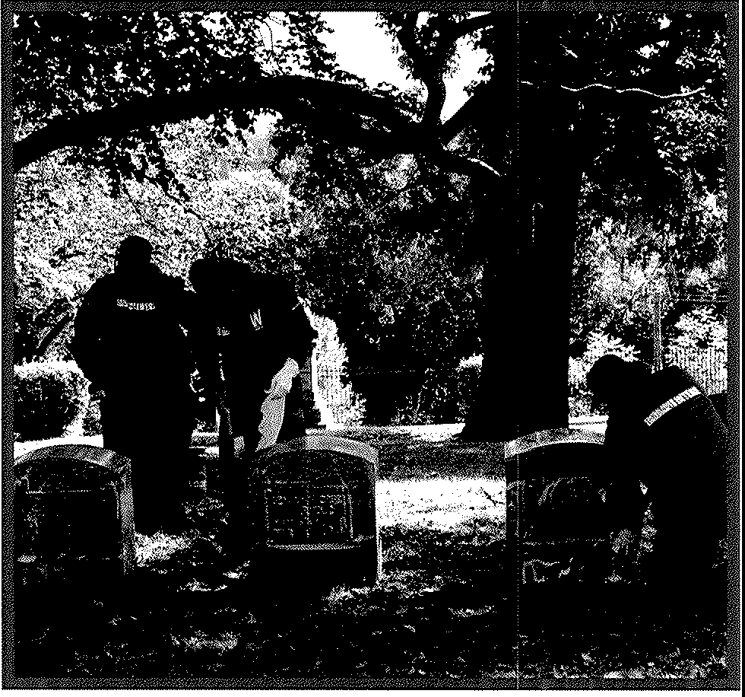
Contact our education division at (518) 474-6226 to learn more and schedule a training session.

