Maplewood Cemetery

Cemetery Volunteer
Visit MaplewoodCemetery.org

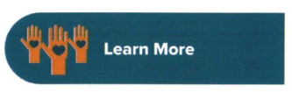
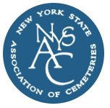

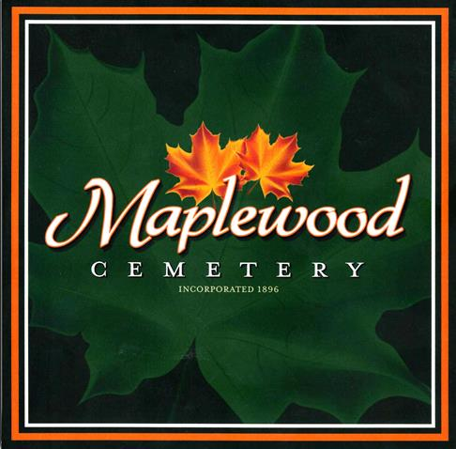
Become a Cemetery
Volunteer
Honor the past, shape the future, contribute to your community.

150 Middle Road
Henrietta, NY 14467

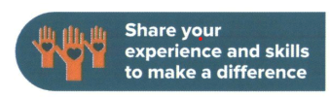

The Division of Cemeteries proudly supports a rich history of cemeteries, regulating approximately 1,700 of
the state's 6,000 cemeteries. These cemeteries are all public not-for-profit corporations.
Most of our cemeteries are small and rely on the dedication of volunteer boards. Volunteers provide essential support and resources to ensure these cherished spaces remain vibrant and well­ maintained, honoring the legacy of those who have come before us.
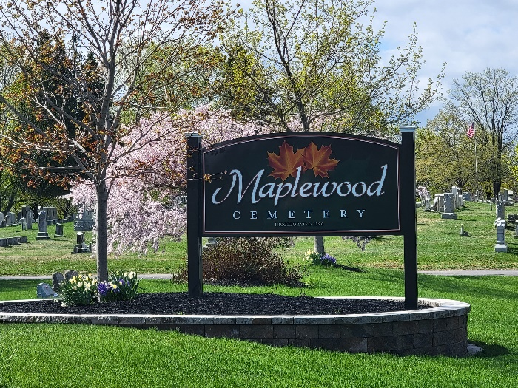Volunteer and join us in our mission to keep New York's cemeteries thriving now and for future generations.

Many of our cemetery boards seek volunteers with various experience and skills. Also, if you are a retiree with a love for community service, we encourage you to consider volunteering your time, talent, and expertise. Whether you're a seasoned expert or just starting out, we have a place for you.
Consider volunteering if you have experience in the following:
- Administration
- Bookkeeping or Filing
- Building and Repair Skills
- Customer Service
- Data Entry
- Grant Writing
- Finance
- Fundraising
- Landscaping or Lawn Maintenance
- Law
- Preservation of Records
- Sales
- Social Media or Marketing
- Surveying

If you are interested in volunteering or finding out more information, please contact Maplewood Cemetery Association (585) 672-1020
or the New York Department of State Division of Cemeteries at (518) 474-6226.

"Volunteers do not necessarily have the time; they have the heart."
- Elizabeth Andrew

