
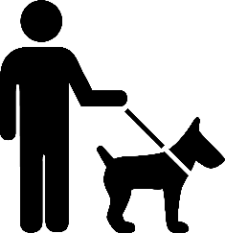
Animal Control
Town of Henrietta
All dogs in the Town of Henrietta are hereby required to be restrained by a leash while off the owner's premises. Please clean up after your pets and keep your pets leashed.
To report violations: Call Henrietta-Animal Control (585) 359-7009

